PROJECT REPORT

ON

**INTERNET SERVICE PROVIDER**

SUBMITTED BY

VINAY DHANANJAY MOHITE

PROJECT GUIDE

Mrs. SMITA N SONAWANE

HOD OF IT DEPARTMENT

Mr. RUPESH S PATIL

SUBMITTED FOR

MATRUSHRI KASHIBHEN MOTILAL PATEL

SENIOR COLLEGE OF COMMERCE AND SCIENCE,

THAKURLI (EAST)

T.Y.B.SC (INFORMATION TECHNOLOGY) 2015-2016

SUBMITTED TO

UNIVERSITY OF MUMBAI



A PROJECT REPORT

ON

INTERNET SERVICE PROVIDER

AS A PARTIAL FULFILLMENT OF

B SC. IT COURSES,

2015 - 16

Submitted for

MATRUSHRI KASHIBEN MOTILAL PATEL

SENIOR COLLEGE OF COMMERCE AND SCIENCE,

THAKURLI (EAST)

AFFILIATED TO

UNIVERSITY OF MUMBAI

DEVELOPED BY:

VINAY DHANANJAY MOHITE

**MATRUSHRI KASHIBEN MOTILAL PATEL**

**SENIOR COLLEGE OF COMMERCE AND SCIENCE,**

**THAKURLI (EAST)**

**BSC –IT (SEM 6)**

Project Certificate for B.Sc.-IT students

This is certifying that the Project entitled **INTERNET SERVICE PROVIDER** submitted by **Mr. VINAY DHANANJAY MOHITE** Seat no._______________ is record of bonafied work carried out by him/her under my guidance, in partial fulfillment of B.SC. IT degree (Semester VI) Examination had not been submitted for any other examination and does not form part of any other course undergone by the candidate.

It is further certified that he /she has completed all required phases of the project.

**____________________ _____________________**

**Signature of Internal Guide Signature of External Examiner**

___________________ ___________________

**Mr. Rupesh Patil Principal,**

**HOD/in charge Mat.K.M.P.College,**

**Thakurli (East).**

**ACKNOWLEDGEMENT**

I express sincere thanks to the HOD of IT Department **Mr. Rupesh Patil** and core faculty of Information Technology. K.M.Patel College of Commerce & Science Thakurli (E) for providing an opportunity to acquire knowledge from corporate world and understand IT business.

I thank my project guide Prof. **Mrs. Smita N. Sonawane and Mrs. Trupti M. Shah** who gave me great and useful suggestion and guidelines. I also thank them for giving us opportunity to work on **“INERNET SERVICE PROVIDER”** project and constant source of inspiration and guidance to us.

Their valuable knowledge and experience helped us to get through the all difficulties. I am grateful to all of them those who have helped me in improving my project which include all useful tips and amendment towards my project.

**PREFACE**

Project is critical to the success of any kind of Modern Business Organization, and hence new projects are constantly being developed to make business more competitive.

In this project report, we have tried to show a various phase of project development like Analysis, Design and Coding. We have included graphical representation like E-R Diagram, System flowchart, etc and screen layouts and source code. Project development and implementations is increasingly technology specific and because of the diverse development environment in the world, we have tried to make the project up to present days expectation.

**T.Y.B.Sc.:- (I.T.)**

**VINAY DHANANJAY MOHITE**

**INDEX**

|  |  |  |
| --- | --- | --- |
| **SR NO** | **CONTENT** | **PG NO** |
| **1.** | **ANALYSIS PHASE**   * 1. **Requirement gathering**      1. Problem statement      2. Fact finding Techniques such as Questionnaires, observation and interview of members of your client      3. Problem with existing system      4. Advantages and Proposed system      5. Objectives and Scope Project      6. Hypothesis of Study      7. Research Methodology      8. Users of Site         1. Types of Users         2. Audience Profile      9. URL   **1.2 Feasibility Study**  1.2.1 Operational Feasibility  1.2.2 Technical Feasibility  1.2.3 Economical Feasibility   * + 1. Cost Benefit Feasibility   **1.3 Requirement Specification**  1.3.1 Functional Requirement  1.3.2 Technical Requirement  1.3.3 Software Requirement Specification  (Accepted requirements and to be signed by both the client and the developer)  1.3.4 Requirement Decomposition Diagram  **1.4 Tools and Technology** |  |
| **2.** | **DATA ANALYSIS AND INTERPRETATION**  **(Questionnaire, Analysis Table, Graphical Representation, Interpretation)** |  |
| **3.** | **DESIGN PHASE**  **3.1 Detailed Life Cycle Of Project**  (Logical Design)  3.1.1 Class Diagram  3.1.2 E-R Diagram  3.1.3 Event Table  3.1.4 Use Case Diagram  3.1.5 Interaction Diagram  3.1.5.1 Collaboration Diagram  3.1.5.2 Sequence Diagram  3.1.6 Activity Diagram  3.1.7 State Chart  **3.2 Physical Diagram**  3.2.1 System Flow Chart |  |
| **4.** | **IMPLEMENTATION PHASE**  **4.1 Coding/ Building**  4.1.1 Screen Layouts  ( Coding is necessary for demo project)  4.1.2 Deployment/ uploading Techniques  **4.2 Testing Phase**  4.2.1 Testing and its types  4.2.2 Methodology Adopted for Testing |  |
| **5.** | **FINDING, SUMMARY & CONCLUSION**  **(Correlation)** |  |
| **6.** | **MAINTAINANCE AND EVALUATION**  6.1 System Maintenance And Future Enhancements  6.2 User Manual / FAQ |  |
| **7.** | **ANNEXURE**  7.1 Reference  7.1.1 Bibliography  7.1.2 Websites Referred  7.2 Questionnaire (Tool 1 and Tool 2)  7.3 Media Page |  |

**INTRODUCTION**

Innovations in computer technologies have revitalized businesses both local markets and worldwide. It enables those small companies to expand into large markets because of its multitasking capabilities that help businesses to handle those completes tasks by the use of computer software. Undeniably, the fast advancement of computer technology is a big help in our society.

Every business of today has its own secret of success. Even those large companies have their own top-secret on how they got that far. A common problem in most businesses is the proper way of monitoring data from their everyday transactions. Through the help of computer technology, this dilemma will quite diminish. Computers have the ability to organize data according to your needs with the aid of your computer programs. By this, it will be easier for the company to trace the flaws in their business and be able to respond to immediately. Therefore, computer technology plays a gigantic role in every business in the community.

The purpose of this document is to express what the engineering community as represented by the T10 expects of Internet Service Providers (ISPs) with respect to security. This document is addressed to ISPs.

By informing ISPs of what this community hopes and expects of them, the community hopes to encourage ISPs to become proactive in making security not only a priority, but something to which they point with pride when selling their services.

In this document we define ISPs to include organizations in the business of providing Internet Connectivity or other Internet services including but not restricted to web hosting services, content providers and e-mail services. We do not include in our definition of an ISP organizations providing those services for their own purposes.

This document is offered as a set of recommendations to ISPs regarding what security and attack management arrangements should be supported, and as advice to users regarding what they should expect from a high quality service provider. It is in no sense normative in its own right. In time it is likely to become dated, and other expectations may arise. However, it does represent a snapshot of the recommendations of a set of professionals in the field at a given point in the development of the Internet and its technology.

**ANALYSIS PHASE**

**1.1 Requirement gathering**

* + 1. **Statement of the problem:**

To study Media as an aid to Market Specifically designed Website.

To study a system the analyst needs to do collect facts and all relevant information. The facts when expressed in quantitative forms are termed as “data”. The success of any project is dependent upon the accuracy of available data. Accurate information can be collected with the help of certain methods. These specific methods for finding information of the system are termed as fat finding techniques. Interview, Questionnaire, Record view, and observations are different fact finding techniques used by analyst. The analyst may use more than one technique for Investigation.

**1.1.2 Fact finding Techniques**

**Interview**

This method is used to collect the information from the group or individual. Analyst selects the people who are related with the system for the interview. In this method the analyst sits face to face with the people and records their responses. The interviewer must plan in advance the type of questions he/she is going to ask and should be ready to answer any type of question. He should also choose a suitable place and time which will be comfortable for the respondent.

The information collected is quite accurate and reliable as the interviewer can clear and cross check the doubts there itself. This method also helps gap the area of misunderstanding and help to discuss about the future problems. Structured and unstructured are the two sub categories of Interview.

Structured interview is more formal interview where fixed questions are asked and specific information is collected whereas unstructured interview is more or less like a casual conversation where-in depth areas topics are covered and all information apart from the topic may also be obtained.

**Questionnaire**

It is the technique used to extract information from number of people. This method can be adopted and used only by a skillful analyst. The questionnaire consists of series of questions framed together in logical manner. The questions are simple, clear and to the point. This method is very useful for attaining information from people who are concerned with the usage of the system and who are living in different countries. The questionnaire can be mailed or can be sent through post. This is the cheapest source of fact finding technique.

**Record View**

The information related to the system is published in the sources like newspaper, magazines, journals, documents etc. this record view helps the analyst to get valuable information about the system and the organization.

**Observation**

Unlike the other fact finding techniques, in this method the analyst himself visits the organization and observes and understands the flow of documents, working of existing system, the users of system etc. for this method to be adopted it takes an analyst to perform this job as he knows which points should be noticed and highlighted. In analyst may observe the unwanted things as well and simply cause delay in the development of the new system.

**1.1.3 Problem with existing system**

**Description of Existing system**

* The current Internet Service provider is handled manually i.e. the data is handled by designed personals. The data is store in the files.
* The processing is done manually, the report generation is slow. Data required cannot be accessed faster.
* The data is stored in various registers to the linking between it is difficult.
* It the lying faces down to manual errors.

**Limitation of Present system**

* **Maintaining details**: Maintaining all the details like member, management, and maintenance is very tedious hob.
* **Excess paper work:** For maintaining records lots of paper gets wasted.
* **Searching is very difficult:** Searching for details about member, his maintenance, worker etc. is tedious.
* **Time consuming:** Due to manual work, it takes lot of time to record a data as well as for searching.
* **Misplacement of records:** Since records are stores in registers so there is high risk of misplacement of records.

Keeping in mind the following above drawback of the proposed system, we would computerized the existing system with the help of programming language, database package case the work of the system up to great extend.

**Description of proposed system**

* The modern computer technology system ease the work of the society on the daily basis.
* It will reduce time consumption of task to be performed.
* All the report will generate on one click only.
* Automatic validation will reduce data entry errors.
* Easy to use.

**1.1.4 ADVANTAGE OF PROPOSED WEBPAGE**

* **GUI:** The proposed system will provide better Graphical User Interface.
* **Increase work speed:** Due to automation of some part of the system work speed will increase.
* **Less paperwork:** For the proposed system less paperwork is required.
* **Reduced errors:** Due to computerized there are less possibilities of errors.

**1.1.5 Objective and scope project**

Our main aim of the project is to get the correct information about particular Internet Service Provider and to reduce efforts.

The main objectives of the system are...

* To create a services based internet provider, whose goal is to exceed customer’s expectations.
* We believe our time management system should be utilized in all activities to provide maximum efficiency and effectiveness for our clients.
* Develop a system that can enhance communication between the internet provider and its clients by the use of email notifications.
* Development of a web page which enables registered user login as administrator or client to view and manage the Appointments.
* To keep the current client happy.

The user can maintain all the records about membership details, monthly maintenance, receipt records, yearly expenditure, accounts maintenance and save it in the database.

* 1. Easy maintenance of all information pertaining to members, accounts, expenditures etc that is to add/ update/ delete record.
  2. Provide all the information about Internet Service Provider at the press of the button.
  3. Design and implement a system that will need a very limited number of people to operate and handle the operation of a system.
  4. Printing of all the documents as and when required, rather than keeping stock of pre-printed stationery and searching around for documents when they are in need.
  5. Transform the information in electronic form so that it can be used for various purposes.

**1.1.6 Hypothesis of study:**

**H0:** Web page may not be effective media to Attract customer’s attention towards the Webpage of Internet Service Provider.

**H1:** Now the null hypothesis has been rejected because there is a chance to purchase the Website if they get as per their requirement in time.

**1.1.7 Research Methodology**

* Source of data: Primary
* Research Area: Kalyan (East)
* Method used for deciding the sample : Selective
* Data collection instrument: Questionnaire
* Research Period: 15 Days
* Field Work: Researcher has selected Internet Service Provider, for marketing- created web page as media, prepared questionnaire containing 10 questions for media i.e. Web pages & 10 questions for Website and collected data from Kalyan.
* Data processing & analysis plan: Correlation, mean, percentage

**1.1.8 User of System**

**1.1.8.1 Types of users**

Many types of users will interact with the proposed examination system.

Depending on the way they interact with the system, users can be categorized as following:

1. Admin
2. Providers

**Admin** will be allowed to:

* Add new providers.
* Add new customers.
* Maintain provider details.
* Maintain customer details.
* Maintain billing records.
* Notify customer about payments.

**Providers** will be allowed to:

* Maintain customer details.
* Maintain plan records.
* Maintain packages records.

**1.1.8.2 Audience Profile**

From the above Questionnaire, we would derive the audience profile as follows:

* Most of the users have old system so they find it difficult to keep track which customer has taken, what is the bill number, etc.
* They use Internet Explorer as Browser.

So we have decided to design a website which consist of many images with low source and it is specifically for1024*764 pixels resolution, website give fast response.

* 1. **Feasibility Study**
     1. **Operational Feasibility**

The user was finding difficulty in storing data and work manual with system. Proposed system will decrease the workload, work time, redundancy of data.

The following findings and conclusion proves that Internet Service provider is operationally feasible.

* 1. The problem is very clear that the need of Internet Service provider record preparation and maintenance cannot meet with the limited staff and manual code of work. So definitely the problem is worth solving.
  2. The alternative to problem is either increase in staff and their increasing plans or by mean of computerizing the existing system. Certainly the later is more beneficial to Internet Service Provider.
     1. **Technical Feasibility**

Front end: Visual Studio 2010

Back end: SQL Server 2008

The following findings and conclusion prove that the Internet Service Provider is technical feasible.

* 1. The requirements from hardware or software point of view are all of the nature, which are readily available and there are no questions about their procurement.
  2. The level of expertise require to develop, deploy and maintain the proposed system is also not going to be an issue, since the required human and machine resources are also available.
     1. **Economic feasibility**

Economic feasibility plays very important role, includes cost for:

1. Website publishing license.

The following findings and conclusion prove that the Internet Service Provider is economic feasible.

* + 1. **Cost Benefit Analysis**

Cost Benefit Analysis (CBA) sometimes called Benefit Cost Analysis (BCA) is a systematic process for calculating and comparing benefits and costs of a project, decision or government policy

CBA has two purposes:

1. To determine if it is a sound investment / decision (justification/ feasibility)
2. To provide a basis for comparing projects. It involves comparing the total expected cost of each option against the total expected benefits, to see whether the benefits outweigh the cost or not.
   1. **REQUIREMENT SPECIFICATION**
      1. **Functional Requirement**

Hardware / software requirements:

|  |  |
| --- | --- |
| Processor Type | Intel Pentium III 733 MHz or higher |
| System RAM | 256 MB |
| Storage Device | 40 GB HDD Minimum |

Hardware / Software to be used:

|  |  |
| --- | --- |
| Operating System | Microsoft Windows 8 |
| Front end | Visual Studio 2010 |
| Back end | SQL Server 2008 |

* + 1. **Requirement Decomposition**

A decomposition diagram shows a high level function, process, organization, data subject area, or other type of object broken down into lower level, more detailed components. For e.g. decomposition diagram may represent organizational structure or functional decomposition into processes. Decomposition diagram provides a logical hierarchical decomposition of a system.

* **Usability:**

The links are provided for each form. The user is facilitated to view and make entries in the forms. Validations are provided in each field to avoid inconsistent or invalid entry in the databases. Some forms consists Hyper Links, which provides further details .Reports screen contains text boxes and drop down lists, so that reports can be produced.

* **Security:**

Application will allow only valid users to access the system. Access to any application resource will depend upon user’s designation. There are users namely Owner. Security is based upon the individual user ID and Password.

* **Maintainability:**

The installation and operation manual of cable & internet service system will be provided to the user**.**

* **Availability:**

System will be available around the clock except for the time required for the backup of the system**.**

* **Portability:**

The application is developed in C#.Net. It would be portable to other operating system provided .NET Framework is available for the OS.As the database is made in DB2,porting the database to another database server would require some development effort.

* **Acceptance Criteria:**

The software should meet the functional requirement and perform the functionality effectively and efficiently.

* A user-friendly interface with proper menus
* Data transfer should be accurate and within a reasonable amount of timekeeping in mind the network traffic.
* The system should not allow entry of duplicate key values.
* System should have the ability to generate transactional Logs to avoid.
* Log file should also be generated.
  1. **Tools and Technology**

Software/ Hardware requirements

Specification:

**Platform**: Windows 8

**Front end**: Visual Studio 2010

**Back end**: SQL Server 2008

**Hardware requirements**: Intel Pentium III 733 MHz or higher 256 MB RAM or higher.

**DATA ANALYSIS AND INTERPRETATION**

**TOOL 1(WEB PAGE)**

|  |  |  |  |  |
| --- | --- | --- | --- | --- |
| Q1.What do you like most about New web page? | | | | |
|  | Image | logo | Punch line | Other |
| % | 31% | 61% | 0% | 8% |
| Response | 4 | 8 | 0 | 1 |
| Total respondents | 13 | 13 | 13 | 13 |

Interpretation:

61% respondents like logo, 31% respondents like image, 8% respondents like other.

|  |  |  |  |  |
| --- | --- | --- | --- | --- |
| Q2.What did you like Least about the Webpage? | | | | |
|  | Image | Logo | Punch line | Other |
| % | 0% | 0% | 77% | 23% |
| Response | 0 | 0 | 10 | 3 |
| Total respondents | 13 | 13 | 13 | 13 |

Interpretation:

77% respondents not like Punch line & 23% respondents not like other

|  |  |  |  |  |
| --- | --- | --- | --- | --- |
| Q3. How will you Rate this Webpage? | | | | |
|  | Excellent | Good | Average | Not Interested |
| % | 61% | 31% | 8% | 0% |
| Response | 8 | 4 | 1 | 0 |
| Total respondents | 13 | 13 | 13 | 13 |

Interpretation:

61% respondents like Excellent, 31% respondents like Good & 8% respondents like Average

|  |  |  |  |  |
| --- | --- | --- | --- | --- |
| Q.4 For how long do you remember a webpage? | | | | |
|  | Remember it all | Remember it slightly | Remember it main content | Don't Remember it all |
| % | 31% | 23% | 38% | 8% |
| Response | 4 | 3 | 5 | 1 |
| Total respondents | 13 | 13 | 10 | 13 |

Interpretation:

31% respondents like Remember it all, 23% respondents like Remember it slightly, 38% respondents like Remember it main content & 8% respondents like Don't Remember it all

|  |  |  |
| --- | --- | --- |
| Q5.Did you like the Webpage? | | |
|  | yes | no |
| % | 92% | 8% |
| Response | 12 | 1 |
| Total respondents | 13 | 13 |

Interpretation:

92% respondents like Yes & 8% respondents like No

|  |  |  |  |  |
| --- | --- | --- | --- | --- |
| Q6. How Long does a Media Impacts on you? | | | | |
|  | Few Hours | One Day | One Week | One Month |
| % | 0% | 8% | 59% | 33% |
| Response | 0 | 1 | 7 | 4 |
| Total respondents | 13 | 13 | 13 | 13 |

Interpretation:

8% respondents like One Day, 59% respondents like One Week & 33% respondents like One Month

|  |  |  |  |  |
| --- | --- | --- | --- | --- |
| Q7.According to you which type of an Advertise gives a Greater Impact? | | | | |
|  | Social Media | TV | Newspaper | Magazine |
| % | 23% | 23% | 31% | 23% |
| Response | 3 | 3 | 4 | 3 |
| Total respondents | 13 | 13 | 13 | 13 |

Interpretation:

31% respondents like Newspaper & 23% respondents like Social media, TV, Magazine

|  |  |  |
| --- | --- | --- |
| Q8. Is this website user friendly? | | |
|  | yes | no |
| % | 100% | 0% |
| Response | 13 | 0 |
| Total respondents | 5 | 5 |

Interpretation:

100% respondents like Yes & 0% respondents like No

|  |  |  |
| --- | --- | --- |
| Q9.Would you like to Visit this website again? | | |
|  | yes | no |
| % | 69% | 31% |
| Response | 9 | 4 |
| Total respondents | 13 | 13 |

Interpretation:

69% respondents like Yes & 31% respondents like No

**Tool 2 Website**

|  |  |  |  |  |
| --- | --- | --- | --- | --- |
| Q1.What is your Budget for this Website? | | | | |
|  | 1000-2000 | 2000-3500 | 3500-5000 | 5000 & Above |
| % | 39% | 31% | 15% | 15% |
| Response | 5 | 4 | 2 | 2 |
| Total respondents | 13 | 13 | 13 | 13 |

Interpretation:

39% respondents like 1000-2000, 31%respondents like 2000-3500, 15% respondents like 3500-5000 & 15% respondents like 5000 & Above

|  |  |  |  |
| --- | --- | --- | --- |
| Q2.What would make you more like to Use this Website? | | | |
|  | Fast Processing | Easy-to-use | User Friendly |
| % | 46% | 8% | 46% |
| Response | 6 | 1 | 6 |
| Total respondents | 13 | 13 | 13 |

Interpretation:

46% respondents like Fast-processing &User-friendly& 8% respondents like Easy-to-use

|  |  |  |  |  |  |  |
| --- | --- | --- | --- | --- | --- | --- |
| Q3.If you were describing this website, what would you say this Website is….. ? | | | | | | |
|  | Boring | Attention Getting | Informative | Strong | Unique | Natural |
| % | 0% | 31% | 54% | 7% | 8% | 0% |
| Response | 0 | 4 | 7 | 1 | 1 | 0 |
| Total respondents | 13 | 13 | 13 | 13 | 13 | 13 |

Interpretation:

31% respondents like Attention getting, 54% respondents like Informative,7% respondents like Strong & 8% respondents like Unique

|  |  |  |
| --- | --- | --- |
| Q4. Is this Website User Friendly? | | |
|  | Yes | No |
| % | 100% | 0% |
| Response | 13 | 0 |
| Total respondents | 13 | 13 |

Interpretation:

100% respondents like yes & 0% respondents like No

|  |  |  |
| --- | --- | --- |
| Q5. Do you like the simplicity of the Website? | | |
|  | Yes | No |
| % | 69% | 31% |
| Response | 9 | 4 |
| Total respondents | 13 | 13 |

Interpretation:

69% respondents like Yes & 31% respondents like No

|  |  |  |
| --- | --- | --- |
| Q6.Do you interest any order placing? | | |
|  | Yes | No |
| % | 23% | 77% |
| Response | 3 | 10 |
| Total respondents | 13 | 3 |

Interpretation:

23% respondents like Yes & 77% respondents like No

|  |  |  |
| --- | --- | --- |
| Q7. Is the Website Fulfilling all your requirements? | | |
|  | Yes | No |
| % | 85% | 15% |
| Response | 11 | 2 |
| Total respondents | 13 | 13 |

Interpretation:

85% respondents like Yes & 15% respondents like No

|  |  |  |
| --- | --- | --- |
| Q8. Do you like the Functionality of the Website? | | |
|  | Yes | No |
| % | 77% | 23% |
| Response | 10 | 3 |
| Total respondents | 13 | 13 |

Interpretation:

77% respondents like Yes & 23% respondents like No

|  |  |  |
| --- | --- | --- |
| Q9. How would you prefer this Website? | | |
|  | Windows based | Web based |
| % | 38% | 62% |
| Response | 5 | 8 |
| Total respondents | 13 | 13 |

Interpretation:

62% respondents like Web based & 38% respondents like Windows based

**Correlation of RT1 and RT2**

|  |  |  |  |
| --- | --- | --- | --- |
|  | Yes | No | Correlation |
| RT1 | 83.76068 | 16.23932 | 1 |
| RT2 | 83.76068 | 16.23932 |  |

Observation The Correlation of research tool1 And Research tool2 is 1

The correlation is positive therefore the null hypotheses is rejected

**DESIGN PHASE**

* 1. **Detailed Life Cycle of Project (Logical Design)**

**Water fall model:**

The waterfall model is the sequential design process often used in software development processes, in which progress is seen as flowing steadily downwards like a waterfall through the phases of Conception, Initiation, Analysis, Design, Construction, Testing, Production / Implementation, and Maintenance.

The waterfall development model originates in the manufacturing and construction industries, highly structured physical environments in which after the fact changes are prohibitively costly, if not possible. Since no formal software development methodology exists at a time, this hardware oriented model was simply adapted for software development.

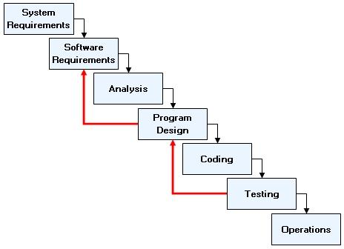

**GANTT CHART ANALYSIS:**

A Gantt chart is a first-rate tool when used by PM’s that seek to envision, prepare, and track estimated and true progress of project. Its graphical way of showing data its executive leadership and frontline staff alike to readily recognize the flow of project, without necessitating a degree and project management, training on how to use Gantt charting software, or even a tutorial about project management. Each occasion we, in our project management careers, go through the effort of our working lives, toiling to meet and exceed the self-set targets, a quiet moment of appreciation extends onwards on Henry Gantt for innovating this easy-to-use diagram to communicate project schedules, as the timeline makes it possible for use to excel as project managers.

**GANTT CHART**

* + 1. **CLASS DIAGRAM**

**Class diagram:**

* It is the structured diagram.
* Structured diagram emphasize what things must be in the system being leveled.
* Class diagram describes the structure of a system by showing the system’s classes, their attributes, and the relationship among the classes.

Class diagram elements:

|  |  |  |
| --- | --- | --- |
| **Notation** | **Description** | |
| Class | | Produces a specification that an object which is the core of development and design |
| Relation | | A line connects between a class and the other class. |

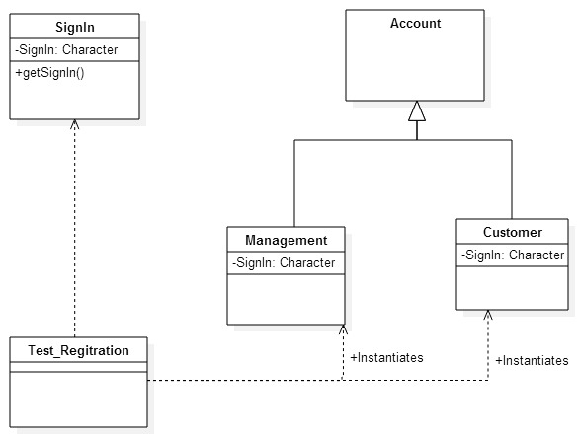

* + 1. **E-R DIAGRAM**

An Entity Relationship Diagram (ERD) is a snapshot of data structures. ERDs show entities in a database and relationships between tables within that database. It is essential to have one of these if you want to create a good database design. We use an Entity Relations Model (ERM) to create a data model of a system and its requirement in a top-down approach. This is frequently the approach utilized in database design.

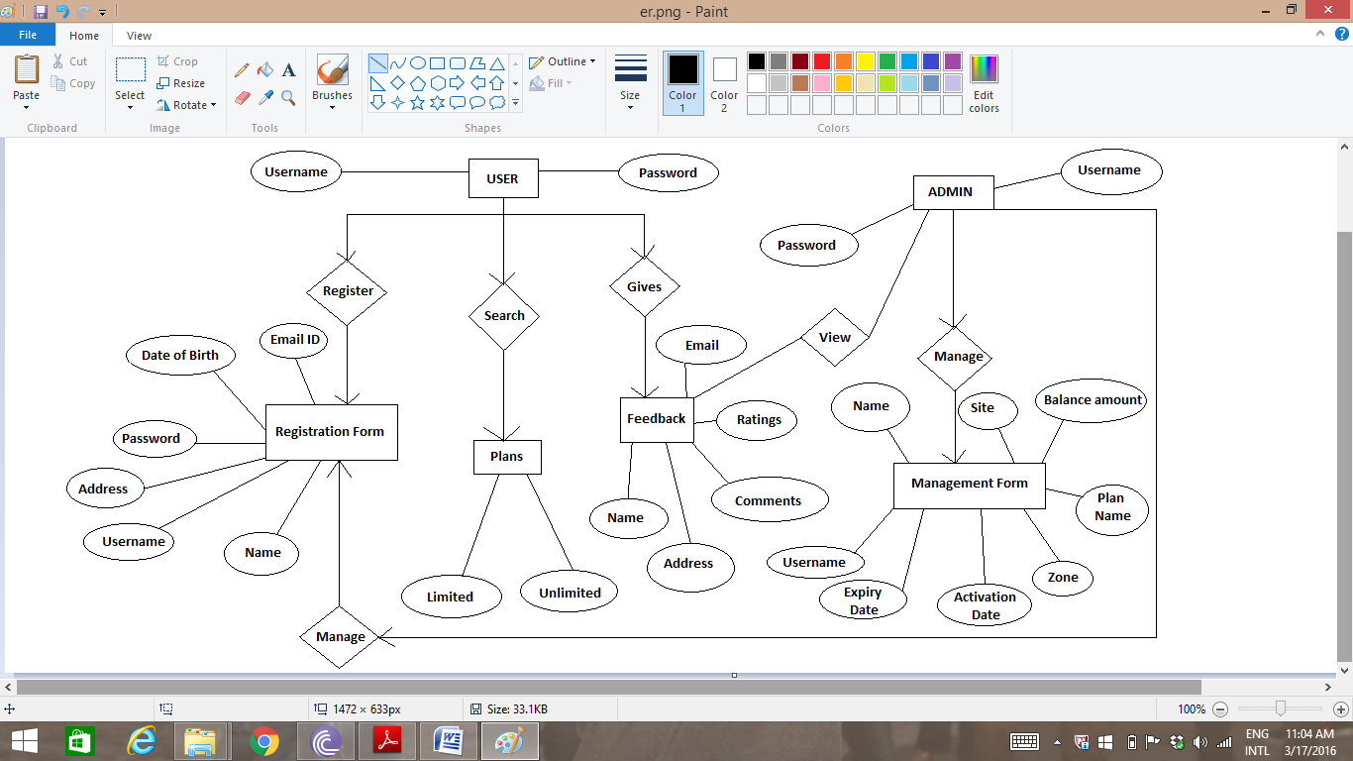

* + 1. **EVENT TABLE**

|  |  |  |  |  |  |  |
| --- | --- | --- | --- | --- | --- | --- |
| **SR NO.** | **EVENT** | **TRIGGER** | **SOURCE** | **ACTIVITY** | **RESPONSE** | **DESTINATION** |
| 1 | Login | Check validity and authentication | System member user | If user is valid then authenticate | Use the system | System |
| 2 | Generate Management | Check Management record | Admin | Enter Details | Created | Member |
| 3 | Generate report | Check Services used | Admin | Enter Details | Created | Member |
| 4 | Registration | Check Websites | User | Enter Complete Details | Created | System |
| 5 | Provide Feedback | Check Websites | User | Enter Complete Details | Created | System |

* + 1. **USE CASE DIAGRAM**

**Use Case diagram:**

The use case diagram is used to identify the primary elements and processes that from the system. The primary elements are as termed as “actors” and the processes are called “use cases”. The use case diagram shows which actors interact with each use case.

|  |  |
| --- | --- |
| **Notation** | **Description** |
| Actor | Basically, the actors are not part of a usecase diagram, but to be able to create a usecase diagram it needs some actors. Actors can only interact with the usecase and does not have control over usecase. |
| Use Case | Function from the use case is to give an illustration of the system that is easily to be understood. |

|  |  |
| --- | --- |
| **Notation** | **Description** |
| Relation include  <<extend>>  <<include>> | Behavior that must be met before an event can occur in conditions where this use case is a part of another use case. |
| Relation extend | Function from the use case is to give an illustration of the system that is easily to be understood. |

Use Case diagrams of UML are used to view a system from this perspective as a set of discrete activities or transactions.

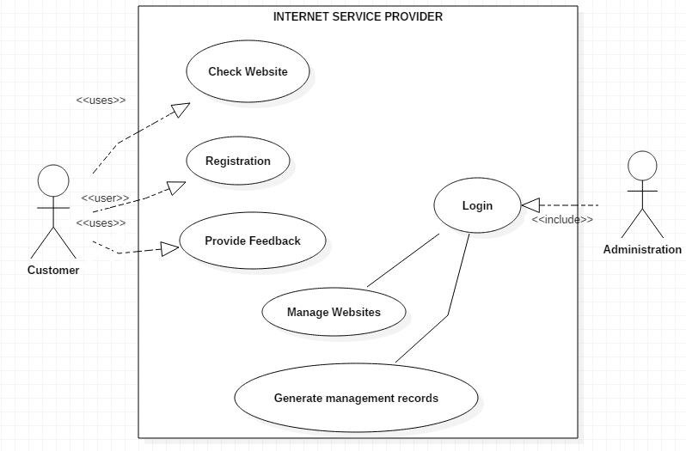

* + 1. **INTERACTION DIAGRAM**

**3.1.5.1 Collaboration Diagram:**

Authentication:

1. Enter Username

2. Enter Password

Administrator Database

3. Authentication Status

Registration:

1. Enters all details

Customer Administrator

2. Check Details

3. Views Details

4. Update

Database

Feedback:

1. Enters all details

Customer Administrator

4. Update

3. Views Details

2. Check Details

Database

**3.1.5.2 Sequence Diagram:**

A sequence diagram is an interaction diagram that detail show operations are carried out. What messages are sent and when. Sequence diagrams are organized according to time. It represents the interaction between different objects in the system. The important aspect of a sequence diagram is that it is time-ordered. This means that the exact sequence of the interactions between the objects is represented step by step. Different objects in the sequence diagram interact with each other by passing “messages”.

|  |  |
| --- | --- |
| **Notation** | **Description** |
| Actor | External represents a person or interactions in system |
| Object | Represents an object that is contained in system or component |
| Lifeline | Identifies the existence of an object in time basis |
| Message | Communication between objects |

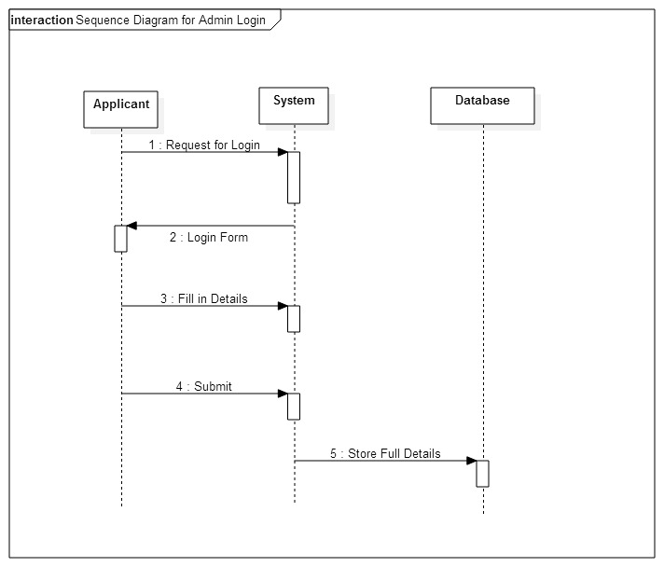

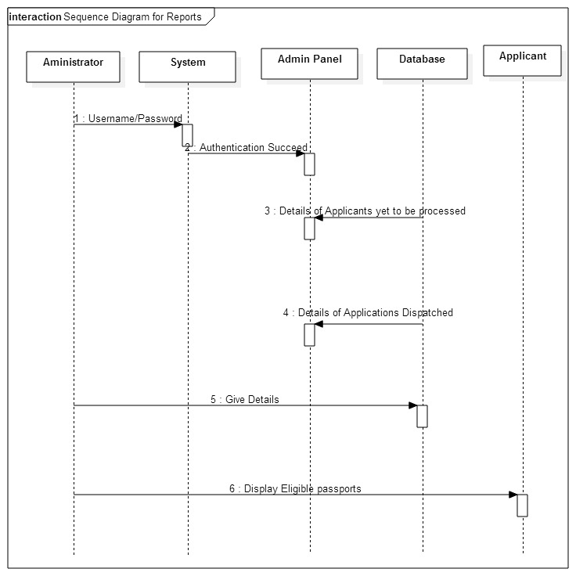

* + 1. **ACTIVITY DIAGRAM**

Activity diagram is a diagram illustrating a flow of activities in the design of a system. Activity diagram shows a sequence of circumstances that are by one object.

|  |  |
| --- | --- |
| **Notation** | **Description** |
| Start State | Beginning of a flow activity |
| End State | Finishing of a flow activity |
| State  NewState | Condition of temporary activity |
| Activity  NewActivity | Use to deliver an activity |
| Decision | A symbol of taking a decision |
| Transmission | A connecting line between the state |

Admin Login

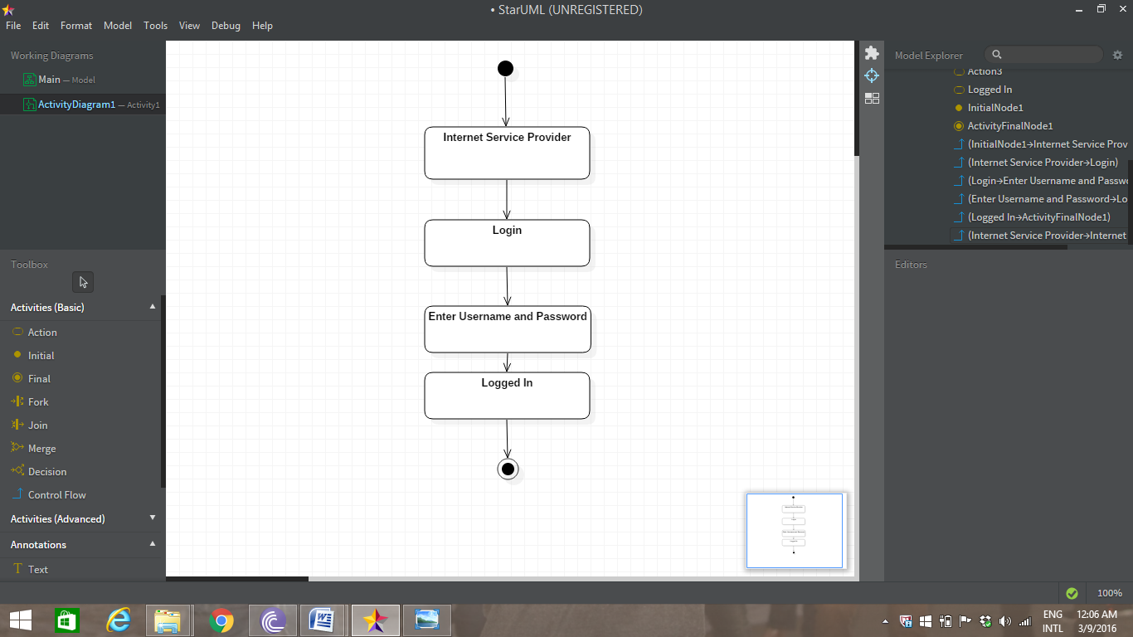

Admin Panel

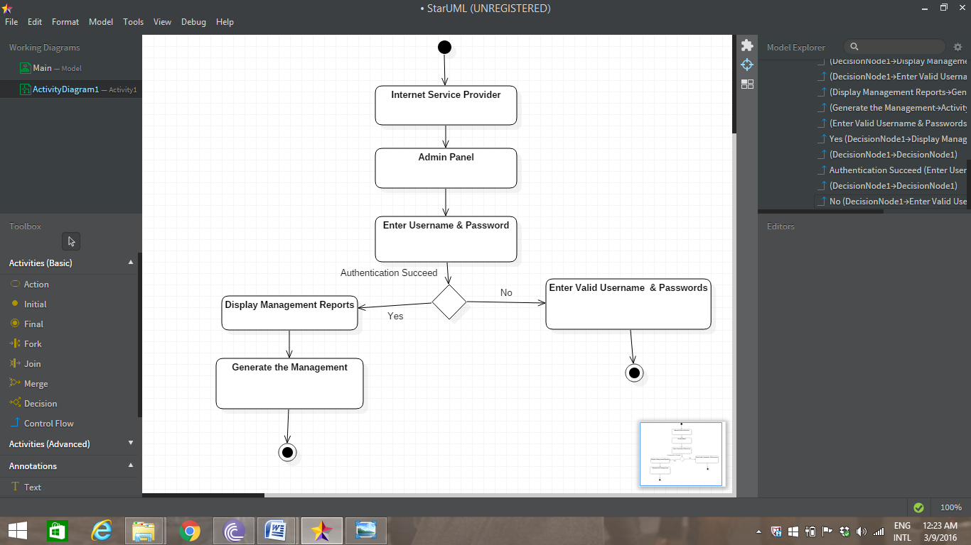

* + 1. **STATE CHART**

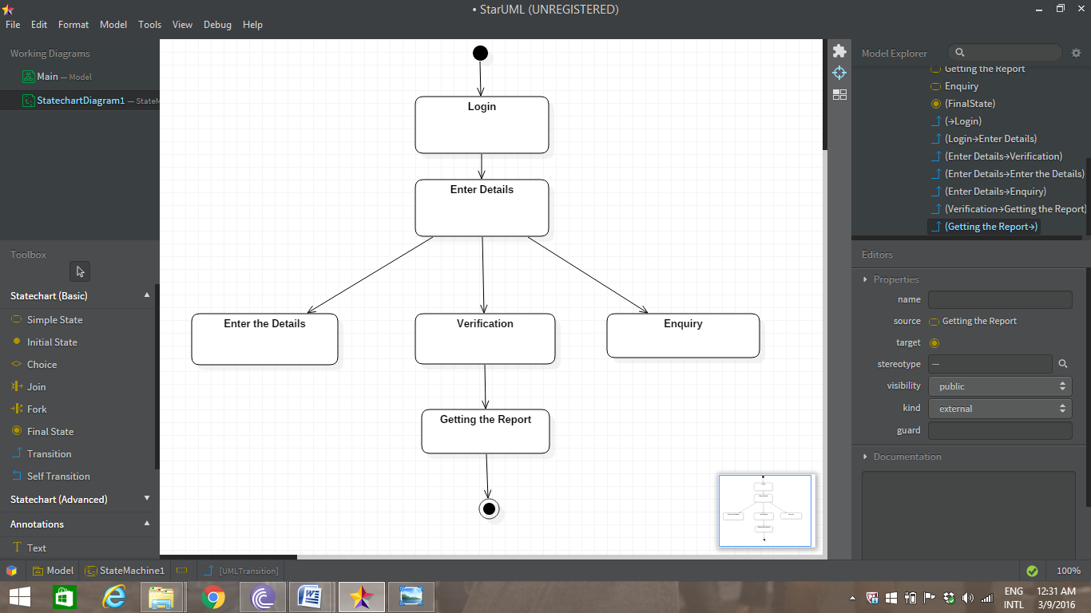

* 1. **PHYSICAL DIAGRAM**

**3.2.1 SYSTEM FLOW CHART**

A Flowchart is a type of diagram that represents an algorithm or process, showing the steps as boxes of various kinds, and their order by connecting these with arrows.

This diagrammatic representation can give a step-by-step solution to a given problem. Process operations are represented in these boxes, and arrows connecting them represent flow of control.

Data flows are not typically represented in a flowchart, in contrast with data flow diagrams; rather, they are implied by the sequencing of operations. Flowcharts are used in analyzing, designing, documenting or managing a process or program in various fields.

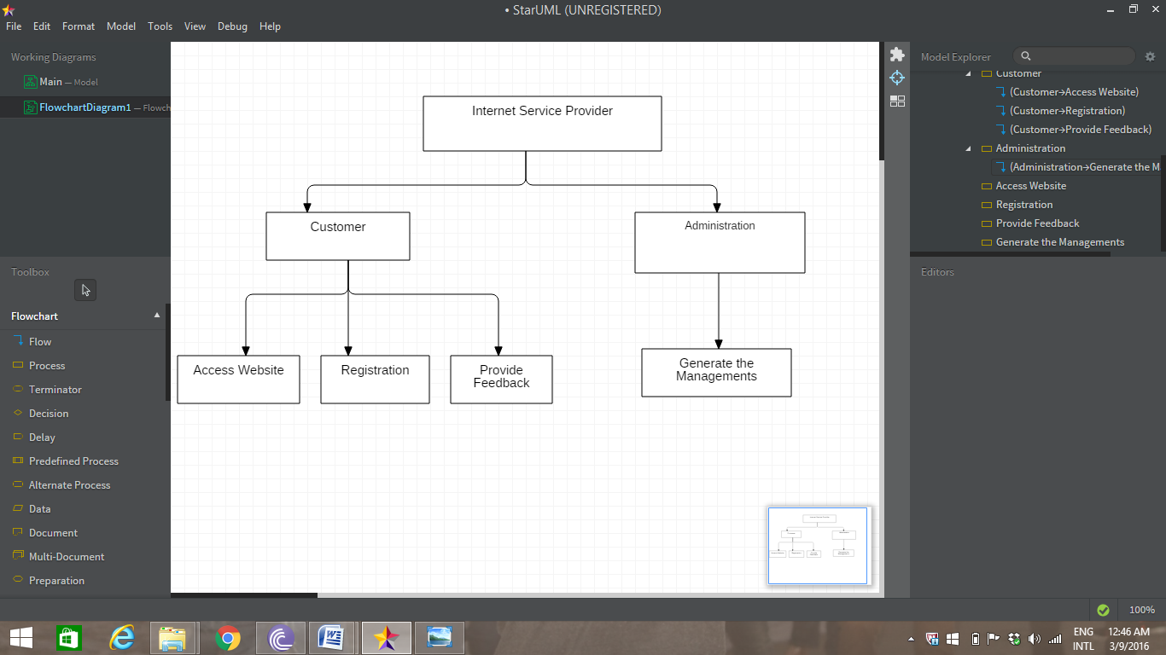

**IMPLEMENTATION PHASE**

**4.1 CODING/BULDING**

When considered as a step in software engineering, coding is viewed as a natural consequence of design. However, programming language characteristics and coding style can profoundly affect software quality and maintainability. The coding step translates a detail design representation into a programming language realization. The translation process continues when a compiler accepts source code as input and produces machine-independent object code as output. Improper interpretation of detail design specification can lead to erroneous source code. Style is important attribute of source code and can determine the intelligibility of a program. The elements of style include internal documentation, methods for data declaration, procedures for statement construction, and I/O coding and declaration. In all cases simplicity and clarity are key characteristics. An offshoot of coding style is the execution time and/or memory efficiency that is achieved. Coding is the phase in which we actually write programs using a programming language. In the coding phase, design must be translated into a machine readable form. If design is performed in a detailed manner, coding can be accomplished mechanistically. It was the only recognized development phase in early or unsystematic development process. The output of this phase is an implemented and tested collection of modules.

**DATA TABLE**

* + 1. Table Name:-Admin

|  |  |  |
| --- | --- | --- |
| **NAME** | **DATA TYPE** | **DESCRIPTION** |
| Username | nvarchar(50) | Username of Admin |
| Password | nvarchar(50) | Password of Admin |

* + 1. Table Name:-Login

|  |  |  |
| --- | --- | --- |
| **NAME** | **DATA TYPE** | **DESCRIPTION** |
| Username | nvarchar(50) | Username of User |
| Password | nvarchar(50) | Password of User |

* + 1. Table Name:-Registration

|  |  |  |
| --- | --- | --- |
| **NAME** | **DATA TYPE** | **DESCRIPTION** |
| Uid | int | UserIDofCustomer |
| Name | nchar(50) | NameofCustomer |
| Age | nchar(10) | AgeofCustomer |
| DateOf Birth | nchar(10) | BirthDateofCustomer |
| Address | nchar(100) | AddressofCustomer |
| Username | nchar(10) | UsernameofCustomer |
| Password | nchar(10) | PasswordofCustomer |
| Email | nchar(50) | EmailofCustomer |
| Contact | nchar(10) | ContactofCustomer |

* + 1. Table Name:-Management

|  |  |  |
| --- | --- | --- |
| **NAME** | **DATA TYPE** | **DESCRIPTION** |
| SrNo | int | UserIDofCustomer |
| Username | nchar(50) | UserNameofCustomer |
| Name | nchar(50) | NameofCustomer |
| Site | nchar(50) | SiteofCustomer |
| Operatorname | nchar(50) | OperatornameofCustomer |
| IPAddress | nchar(50) | IPAddressofCustomer |
| ActivationDate | nchar(50) | ActivationDateofCustomer |
| RenewDate | nchar(50) | RenewDateofCustomer |
| ExpiryDate | nchar(50) | ExpiryDateofCustomer |
| PlanName | nchar(50) | PlanNameofCustomer |
| ZoneName | nchar(50) | ZoneNameofCustomer |
| BuildingName | nchar(50) | BuildingName ofCustomer |
| BalanceAmount | nchar(50) | BalanceAmountofCustomer |

**4.1.1 Screen Layouts**

**HOME PAGE**

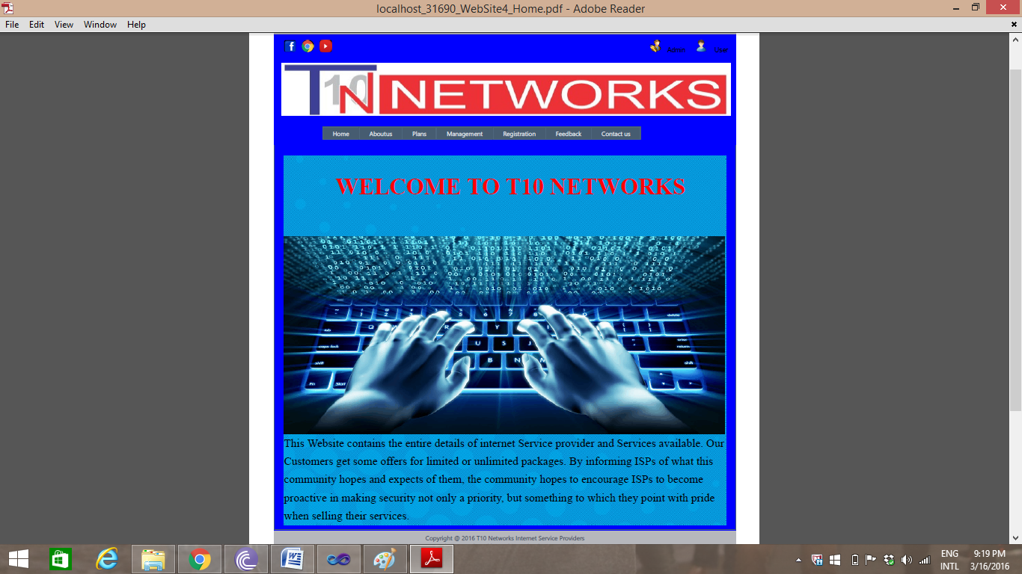

ABOUT US

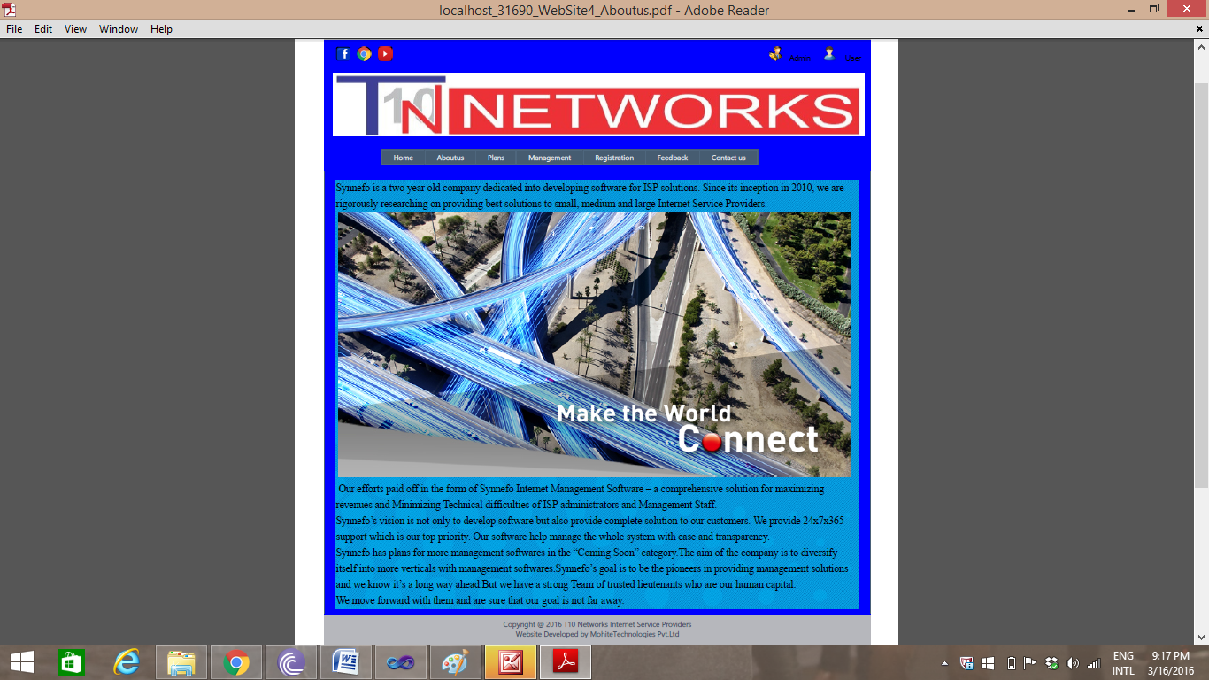

**PLANS**

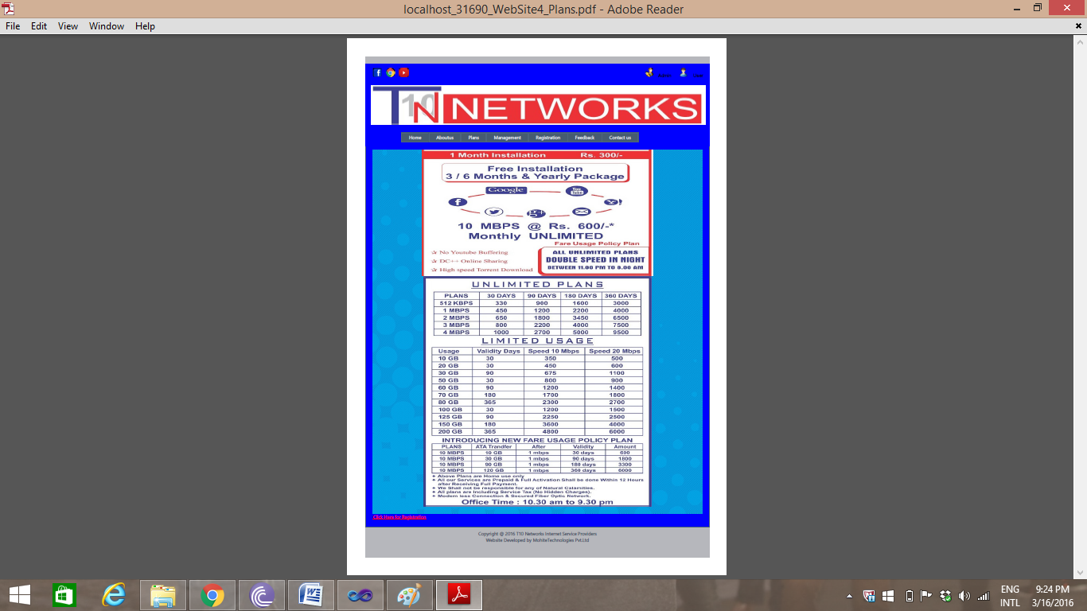

**REGISTRATION**

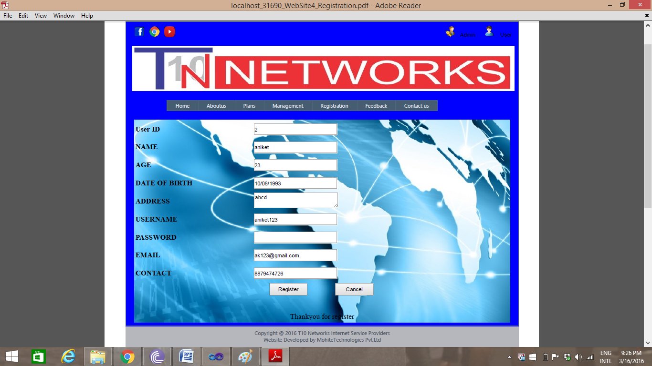

**ADMIN**

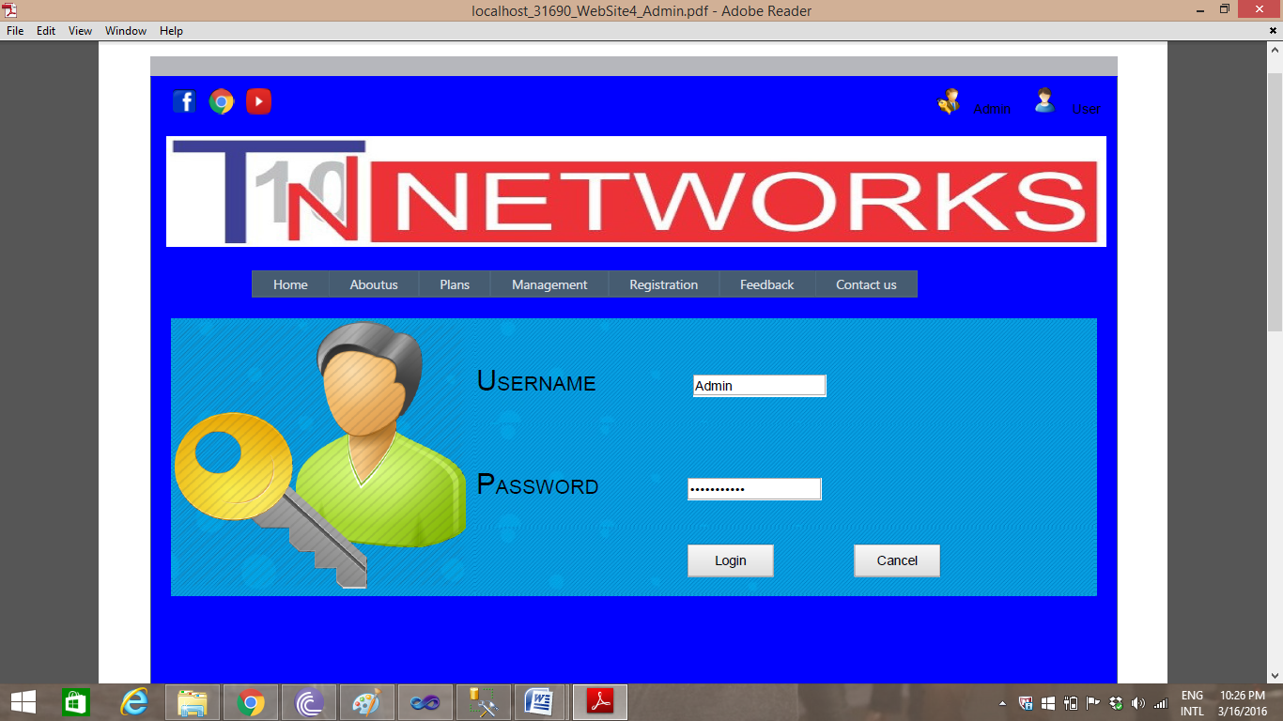

**MANAGEMNET**

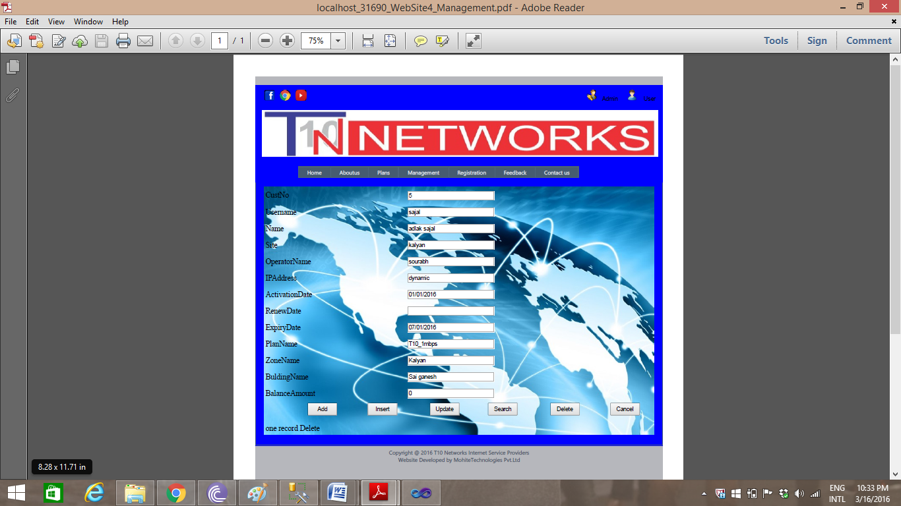

**USER LOGIN**

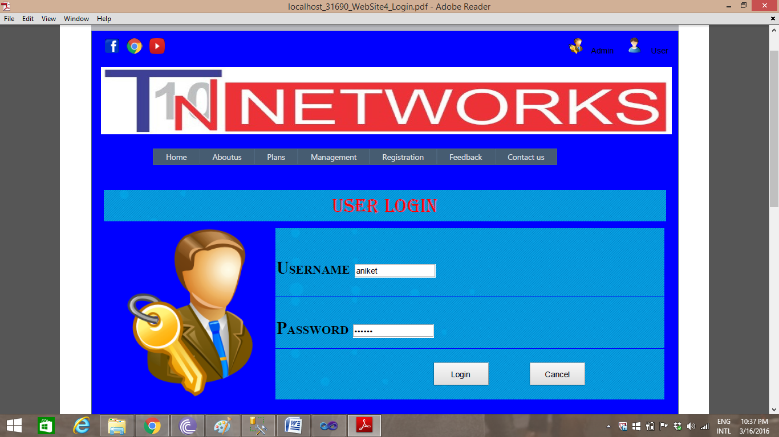

**USER FEEDBACK**

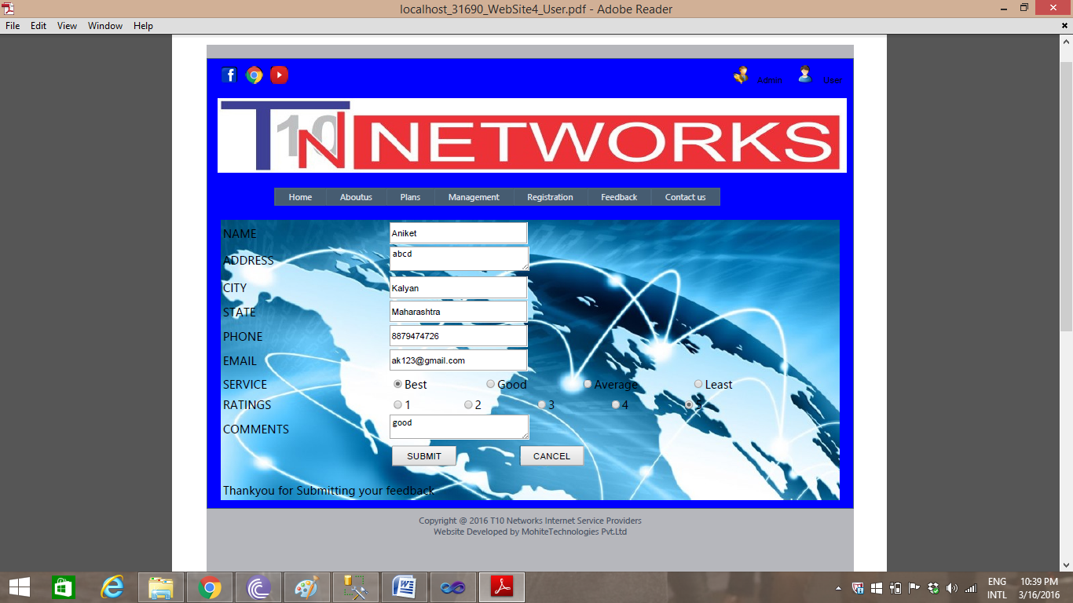

**CONTACT US**

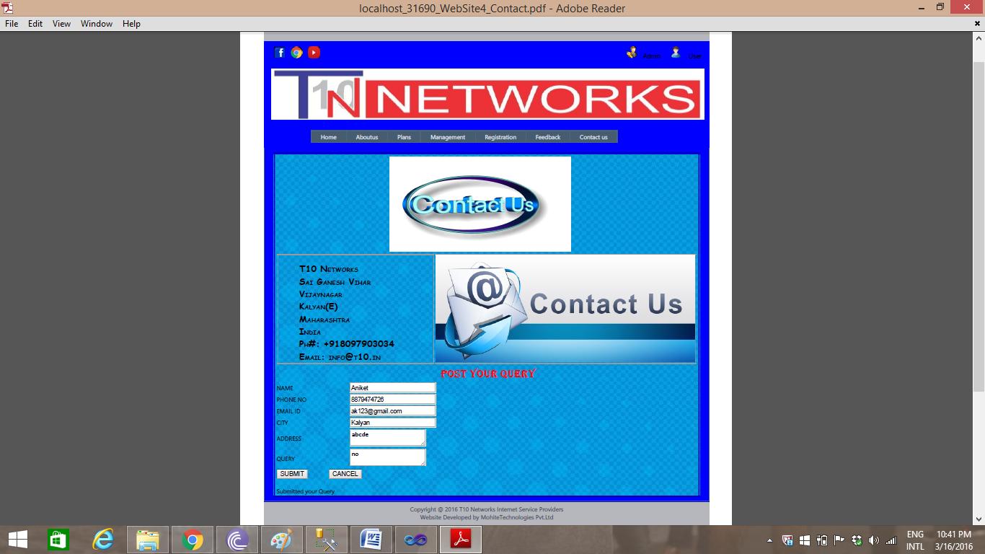

**CODING**

**ADMIN LOGIN PAGE**

Admin.aspx

<%@ Page Title="" Language="C#" MasterPageFile="~/Site.master" AutoEventWireup="true" CodeFile="Admin.aspx.cs" Inherits="Admin" %>

<asp:Content ID="Content1" ContentPlaceHolderID="HeadContent" Runat="Server">

<style type="text/css">

.style1

{

width: 920px;

}

.style2

{

width: 296px;

}

</style>

</asp:Content>

<asp:Content ID="Content2" ContentPlaceHolderID="MainContent" Runat="Server">

<table class="style1"

style="font-size: large; font-family: Arial; color: #000000; background-image: url('img/1886497.jpg');">

<tr>

<td class="style2" rowspan="3" style="background-image: url('img/1886497.jpg'); border-color: #0000FF">

<asp:Image ID="Image2" runat="server" ImageUrl="~/img/user_login_man-512.png"

Width="289px" Height="265px" />

</td>

<td style="border-color: #0000FF; background-image: url('img/1886497.jpg')">

<h1 style="color: #000000"> Username&nbsp;&nbsp;&nbsp;&nbsp;&nbsp;&nbsp;&nbsp;&nbsp;&nbsp;&nbsp;&nbsp;

<asp:TextBox ID="TextBox2" runat="server" Width="128px"></asp:TextBox>

<asp:RequiredFieldValidator ID="RequiredFieldValidator1" runat="server"

ControlToValidate="TextBox2" ErrorMessage="Please enter username"

Font-Size="Smaller" ForeColor="Red"></asp:RequiredFieldValidator>

</h1>

</td>

</tr>

<tr>

<td style="border-color: #0000FF; background-image: url('img/1886497.jpg')">

<h1 style="color: #000000"> Password&nbsp;&nbsp;&nbsp;&nbsp;&nbsp;&nbsp;&nbsp;&nbsp;&nbsp;&nbsp;

<asp:TextBox ID="TextBox3" runat="server" TextMode="Password" Width="128px"></asp:TextBox>

<asp:RequiredFieldValidator ID="RequiredFieldValidator2" runat="server"

ControlToValidate="TextBox3" ErrorMessage="Please enter password"

Font-Size="Smaller" ForeColor="Red"></asp:RequiredFieldValidator>

</h1>

</td>

</tr>

<tr>

<td style="border-color: #0000FF; background-image: url('img/1886497.jpg');">

&nbsp;&nbsp;&nbsp;&nbsp;&nbsp;&nbsp;&nbsp;&nbsp;&nbsp;&nbsp;&nbsp;&nbsp;&nbsp;&nbsp;&nbsp;&nbsp;&nbsp;&nbsp;&nbsp;&nbsp;&nbsp;&nbsp;&nbsp;&nbsp;&nbsp;&nbsp;&nbsp;&nbsp;&nbsp;&nbsp;&nbsp;&nbsp;&nbsp;&nbsp;&nbsp;&nbsp;&nbsp;&nbsp;&nbsp;&nbsp;&nbsp;&nbsp;<asp:Button

ID="Button1" runat="server" onclick="Button1_Click" Text="Login" Height="33px"

Width="86px" />

&nbsp;&nbsp;&nbsp;&nbsp;&nbsp;&nbsp;&nbsp;&nbsp;&nbsp;&nbsp;&nbsp;&nbsp;&nbsp;&nbsp;

<asp:Button ID="Button4" runat="server" Height="33px" onclick="Button4_Click"

Text="Cancel" Width="86px" />

</td>

</tr>

</table>

</asp:Content>

Admin.aspx.cs

using System;

using System.Collections.Generic;

using System.Linq;

using System.Web;

using System.Web.UI;

using System.Web.UI.WebControls;

using System.Data.SqlClient;

using System.Data;

public partial class Admin : System.Web.UI.Page

{

protected void Page_Load(object sender, EventArgs e)

{

}

protected void Button1_Click(object sender, EventArgs e)

{

SqlConnection con = new SqlConnection("Data Source=DHANANJAY;Initial Catalog=ISP;Integrated Security=True");

con.Open();

SqlCommand cmd = new SqlCommand("Select Username, Password from Admin where username='" + TextBox2.Text + "' and password ='" + TextBox3.Text + "'", con);

SqlDataAdapter da = new SqlDataAdapter(cmd);

DataTable dt = new DataTable();

da.Fill(dt);

if (dt.Rows.Count > 0)

{

Response.Redirect("Management.aspx");

}

else

{

Response.Write("<script>alert('Please enter valid Username and Password')</script>");

}

}

protected void Button4_Click(object sender, EventArgs e)

{

Response.Redirect("Home.aspx");

}

}

**MANAGEMENT**

Management.aspx

<%@ Page Title="" Language="C#" MasterPageFile="~/Site.master" AutoEventWireup="true" CodeFile="Management.aspx.cs" Inherits="Management" %>

<asp:Content ID="Content1" ContentPlaceHolderID="HeadContent" Runat="Server">

<style type="text/css">

.style1

{

width: 100%;

}

.style3

{

height: 68px;

}

.style4

{

height: 35px;

}

.style5

{

height: 35px;

width: 6px;

}

</style>

</asp:Content>

<asp:Content ID="Content2" ContentPlaceHolderID="MainContent" Runat="Server">

<table class="style1"

style="font-family: 'Times New Roman', Times, serif; font-size: large;background-image: url('img/Best-ISP-in-Toronto-1200x900.jpg'); color: #000000">

<tr>

<td class="style5" >

CustNo

</td>

<td class="style4">

<asp:TextBox ID="TextBox1" runat="server" Width="200px"></asp:TextBox>

</td>

</tr>

<tr>

<td class="style5">

Username</td>

<td class="style4">

<asp:TextBox ID="TextBox2" runat="server" Width="200px"></asp:TextBox>

&nbsp;&nbsp;&nbsp;&nbsp;&nbsp;&nbsp;&nbsp;&nbsp;&nbsp;&nbsp;&nbsp;&nbsp;&nbsp;&nbsp;&nbsp;&nbsp;&nbsp;&nbsp;&nbsp;&nbsp;&nbsp;&nbsp;&nbsp;&nbsp;&nbsp;&nbsp;&nbsp;&nbsp;&nbsp;&nbsp;&nbsp;&nbsp;&nbsp;&nbsp;&nbsp;&nbsp;&nbsp;&nbsp;&nbsp;&nbsp;&nbsp;&nbsp;&nbsp;&nbsp;&nbsp;&nbsp;&nbsp;&nbsp;&nbsp;&nbsp;&nbsp;&nbsp;

</td>

</tr>

<tr>

<td class="style5">

Name</td>

<td class="style4">

<asp:TextBox ID="TextBox3" runat="server" style="margin-left: 0px"

Width="200px"></asp:TextBox>

</td>

</tr>

<tr>

<td class="style5">

Site</td>

<td class="style4">

<asp:TextBox ID="TextBox4" runat="server" Width="200px"></asp:TextBox>

</td>

</tr>

<tr>

<td class="style5">

OperatorName</td>

<td class="style4" >

<asp:TextBox ID="TextBox5" runat="server" Width="200px"></asp:TextBox>

</td>

</tr>

<tr>

<td class="style5">

IPAddress</td>

<td class="style4">

<asp:TextBox ID="TextBox6" runat="server" Width="200px"></asp:TextBox>

</td>

</tr>

<tr>

<td class="style5">

ActivationDate</td>

<td class="style4">

<asp:TextBox ID="TextBox7" runat="server" Width="200px"></asp:TextBox>

</td>

</tr>

<tr>

<td class="style5">

RenewDate</td>

<td class="style4">

<asp:TextBox ID="TextBox8" runat="server" Width="200px"></asp:TextBox>

</td>

</tr>

<tr>

<td class="style5">

ExpiryDate</td>

<td class="style4" >

<asp:TextBox ID="TextBox9" runat="server" Width="200px"></asp:TextBox>

</td>

</tr>

<tr>

<td class="style5">

PlanName</td>

<td class="style4">

<asp:TextBox ID="TextBox10" runat="server" Width="200px"></asp:TextBox>

</td>

</tr>

<tr>

<td class="style5">

ZoneName</td>

<td class="style4">

<asp:TextBox ID="TextBox11" runat="server" Width="200px"></asp:TextBox>

</td>

</tr>

<tr>

<td class="style5">

BuldingName</td>

<td class="style4">

<asp:TextBox ID="TextBox12" runat="server" Width="200px"></asp:TextBox>

</td>

</tr>

<tr>

<td class="style5">

BalanceAmount</td>

<td class="style4">

<asp:TextBox ID="TextBox13" runat="server" Width="200px"></asp:TextBox>

</td>

</tr>

<tr>

<td class="style3" colspan="2" >

&nbsp;&nbsp;&nbsp;&nbsp;&nbsp;&nbsp;&nbsp;&nbsp;&nbsp;&nbsp;&nbsp;&nbsp;&nbsp;&nbsp;&nbsp;&nbsp; &nbsp;&nbsp;&nbsp;&nbsp;&nbsp;<asp:Button

ID="Button7" runat="server" onclick="Button7_Click" Text="Add"

Height="30px" Width="70px" />

&nbsp;&nbsp;&nbsp;&nbsp;&nbsp;

&nbsp;&nbsp;&nbsp;&nbsp;&nbsp;&nbsp;&nbsp;&nbsp;&nbsp;<asp:Button ID="Button1" runat="server"

onclick="Button1_Click" Text="Insert" Height="30px" Width="70px" />

&nbsp;&nbsp;&nbsp;&nbsp;&nbsp;&nbsp;&nbsp;&nbsp;&nbsp;

&nbsp;&nbsp;&nbsp;&nbsp;&nbsp;&nbsp;<asp:Button ID="Button2" runat="server"

onclick="Button2_Click" Text="Update" Height="30px" Width="70px" />

&nbsp;&nbsp;&nbsp;&nbsp;&nbsp;&nbsp;&nbsp;&nbsp;&nbsp;&nbsp;&nbsp;&nbsp;&nbsp;

<asp:Button ID="Button5" runat="server" Text="Search" onclick="Button5_Click"

Height="30px" Width="70px" />

&nbsp;&nbsp;&nbsp;&nbsp;&nbsp;&nbsp;&nbsp;&nbsp;&nbsp;&nbsp;&nbsp;&nbsp;&nbsp;&nbsp;&nbsp;

<asp:Button ID="Button4" runat="server" Height="30px" Text="Delete"

onclick="Button4_Click" Width="70px" />

&nbsp;&nbsp;&nbsp;&nbsp;&nbsp;&nbsp;&nbsp;&nbsp;&nbsp;&nbsp;&nbsp;&nbsp;&nbsp;&nbsp;

<asp:Button ID="Button6" runat="server" Text="Cancel" onclick="Button6_Click"

Height="30px" Width="70px" />

<br />

<br />

<asp:Literal ID="Literal1" runat="server"></asp:Literal>

</td>

</tr>

</table>

&nbsp;&nbsp;&nbsp;&nbsp;&nbsp;&nbsp;&nbsp;&nbsp;&nbsp;&nbsp;&nbsp;&nbsp;&nbsp;&nbsp;&nbsp;&nbsp;&nbsp;&nbsp;&nbsp;&nbsp;&nbsp;

</asp:Content>

Management.aspx.cs

using System;

using System.Collections.Generic;

using System.Linq;

using System.Web;

using System.Web.UI;

using System.Web.UI.WebControls;

using System.Data;

using System.Data.SqlClient;

public partial class Management : System.Web.UI.Page

{

SqlConnection conn = new SqlConnection("Data Source=DHANANJAY;Initial Catalog=ISP;Integrated Security=True");

SqlCommand cmd = new SqlCommand();

SqlDataReader sqldr;

string g; int i;

public void auto()

{

if (conn.State == ConnectionState.Open)

conn.Close();

conn.Open();

cmd = conn.CreateCommand();

cmd.CommandText = "select max(SrNo) from Management";

sqldr = cmd.ExecuteReader();

if (sqldr.Read())

{

// g = sqldr.GetString(0);

i = sqldr.GetInt32(0);

}

TextBox1.Text = Convert.ToString(1 + i);

TextBox2.Focus();

conn.Close();

}

protected void Page_Load(object sender, EventArgs e)

{

}

protected void Button1_Click(object sender, EventArgs e)

{

//String strconn = "Data Source=DHANANJAY;Initial Catalog=ISP;Integrated Security=True";

//SqlConnection conn = new SqlConnection(strconn);

//SqlCommand cmd = new SqlCommand();

conn.Open();

cmd.Connection = conn;

int aa = Convert.ToInt32(TextBox1.Text);

String bb = TextBox2.Text;

String cc = TextBox3.Text;

String dd = TextBox4.Text;

String ee = TextBox5.Text;

String ff = TextBox6.Text;

String gg = TextBox7.Text;

String hh = TextBox8.Text;

String ii = TextBox9.Text;

String jj = TextBox10.Text;

String kk = TextBox11.Text;

String ll = TextBox12.Text;

String mm = TextBox13.Text;

cmd = new SqlCommand("Insert into Management(SrNo,Username,Name,Site,OperatorName,IPAddress,ActivationDate,RenewDate,ExpiryDate,PlanName,ZoneName,BuildingName,BalanceAmount)values('" + aa + "','" + bb + "','" + cc + "','" + dd + "','" + ee + "','" + ff + "','" + gg + "','" + hh + "','" + ii + "','" + jj + "','" + kk + "','" + ll + "','" + mm + "')", conn);

cmd.CommandType = CommandType.Text;

cmd.ExecuteNonQuery();

conn.Close();

Literal1.Text = "Thankyou for register";

}

protected void Button2_Click(object sender, EventArgs e)

{

conn.Open();

int aa = Convert.ToInt32(TextBox1.Text);

String bb = TextBox2.Text;

String cc = TextBox3.Text;

String dd = TextBox4.Text;

String ee = TextBox5.Text;

String ff = TextBox6.Text;

String gg = TextBox7.Text;

String hh = TextBox8.Text;

String ii = TextBox9.Text;

String jj = TextBox10.Text;

String kk = TextBox11.Text;

String ll = TextBox12.Text;

String mm = TextBox13.Text;

string abc = "UPDATE Management SET SrNo =" + aa + ",Username ='" + bb + "' ,Name ='" + cc + "',Site ='" + dd + "',OperatorName ='" + ee + "',IPAddress ='" + ff + "',ActivationDate ='" + gg + "',RenewDate ='" + hh + "',ExpiryDate ='" + ii + "',PlanName ='" + jj + "',ZoneName ='" + kk + "',BuildingName ='" + ll + "',BalanceAmount ='" + mm + "' WHERE Username = '" + bb + "'";

SqlCommand cmd = new SqlCommand(abc, conn);

cmd.ExecuteNonQuery();

Literal1.Text="one record updated";

conn.Close();

}

protected void Button5_Click(object sender, EventArgs e)

{

if (conn.State == ConnectionState.Open)

conn.Close();

conn.Open();

SqlDataAdapter adp;

DataSet ds;

DataRow dr;

DataTable dt;

adp = new SqlDataAdapter("select * from management", conn);

ds = new DataSet();

adp.Fill(ds, "temp");

dt = ds.Tables["temp"];

dt.PrimaryKey = new DataColumn[] { dt.Columns["username"] };

string bb = TextBox2.Text;

dr = dt.Rows.Find(bb);

if (dr != null)

{

TextBox1.Text = dr[0].ToString();

TextBox2.Text = dr[1].ToString();

TextBox3.Text = dr[2].ToString();

TextBox4.Text = dr[3].ToString();

TextBox5.Text = dr[4].ToString();

TextBox6.Text = dr[5].ToString();

TextBox7.Text = dr[6].ToString();

TextBox8.Text = dr[7].ToString();

TextBox9.Text = dr[8].ToString();

TextBox10.Text = dr[9].ToString();

TextBox11.Text = dr[10].ToString();

TextBox12.Text = dr[11].ToString();

TextBox13.Text = dr[12].ToString();

Button2.Enabled = true;

}

else

{

Literal1.Text = "Not Found";

}

}

protected void Button7_Click(object sender, EventArgs e)

{

auto();

}

protected void Button4_Click(object sender, EventArgs e)

{

conn.Open();

string bb = TextBox2.Text;

cmd = new SqlCommand("DELETE FROM Management WHERE Username = '" + bb + "'", conn);

cmd.ExecuteNonQuery();

Literal1.Text="one record Delete";

conn.Close();

}

protected void Button6_Click(object sender, EventArgs e)

{

TextBox1.Text = "";

TextBox2.Text = "";

TextBox3.Text = "";

TextBox4.Text = "";

TextBox5.Text = "";

TextBox6.Text = "";

TextBox7.Text = "";

TextBox8.Text = "";

TextBox9.Text = "";

TextBox10.Text = "";

TextBox11.Text = "";

TextBox12.Text = "";

TextBox13.Text = "";

}

}

**USER LOGIN PAGE**

**Login.aspx**

<%@ Page Title="" Language="C#" MasterPageFile="~/Site.master" AutoEventWireup="true" CodeFile="Login.aspx.cs" Inherits="Login" %>

<asp:Content ID="Content1" ContentPlaceHolderID="HeadContent" Runat="Server">

<style type="text/css">

.style1

{

width: 919px;

height: 256px;

}

.style2

{

width: 252px;

}

.style3

{

text-align: center;

}

.style4

{

height: 82px;

}

</style>

</asp:Content>

<asp:Content ID="Content2" ContentPlaceHolderID="MainContent" Runat="Server">

<p class="style3" style="font-family: Algerian; font-size: xx-large; background-image: url('img/1886497.jpg'); color: #FF0000;">

USER LOGIN</p>

<table class="style1">

<tr>

<td class="style2" rowspan="3">

<asp:Image ID="Image2" runat="server" ImageUrl="~/img/login_icon.jpg"

Width="275px" />

</td>

<td style="background-image: url('img/1886497.jpg'); color: #000000; font-size: large; font-family: 'Times New Roman', Times, serif;">

<h1 style="background-image: url('img/1886497.jpg'); font-family: Arial;">

<b style="color: #000000; font-family: 'Times New Roman', Times, serif">Username</b>

<asp:TextBox ID="TextBox2" runat="server" Width="128px"></asp:TextBox>

&nbsp;<asp:RequiredFieldValidator ID="RequiredFieldValidator1" runat="server"

ControlToValidate="TextBox2" ErrorMessage="Please Enter User Name"

Font-Names="Times New Roman" Font-Size="Large" ForeColor="Red"></asp:RequiredFieldValidator>

</h1>

</td>

</tr>

<tr>

<td class="style4" style="background-image: url('img/1886497.jpg'); color: #000000; font-size: large; font-family: 'Times New Roman', Times, serif;">

<h1 style="font-family: 'Times New Roman', Times, serif">

<b style="color: #000000; font-family: 'Times New Roman', Times, serif">Password</b>

<asp:TextBox ID="TextBox3" runat="server" TextMode="Password" Width="128px"></asp:TextBox>

<asp:RequiredFieldValidator ID="RequiredFieldValidator2" runat="server"

ControlToValidate="TextBox3" ErrorMessage="Please Enter Password"

Font-Names="Times New Roman" Font-Size="Large" ForeColor="Red"></asp:RequiredFieldValidator>

</h1>

</td>

</tr>

<tr>

<td style="background-image: url('img/1886497.jpg'); color: #000000; font-size: large; font-family: 'Times New Roman', Times, serif;">

&nbsp;&nbsp;&nbsp;&nbsp;&nbsp;&nbsp;&nbsp;&nbsp;&nbsp;&nbsp;&nbsp;&nbsp;&nbsp;&nbsp;&nbsp;&nbsp;&nbsp;&nbsp;&nbsp;&nbsp;&nbsp;&nbsp;&nbsp;&nbsp;&nbsp;&nbsp;&nbsp;&nbsp;&nbsp;&nbsp;&nbsp;&nbsp;&nbsp;&nbsp;&nbsp;&nbsp;&nbsp;&nbsp;&nbsp;&nbsp;&nbsp;&nbsp;&nbsp;&nbsp;&nbsp;&nbsp;&nbsp;&nbsp;&nbsp;&nbsp;&nbsp;&nbsp;&nbsp;&nbsp;&nbsp;&nbsp;

<asp:Button ID="Button1" runat="server" onclick="Button1_Click" Text="Login"

Height="38px" Width="91px" />

&nbsp;&nbsp;&nbsp;&nbsp;&nbsp;&nbsp;&nbsp;&nbsp;&nbsp;&nbsp;&nbsp;&nbsp;&nbsp;

<asp:Button ID="Button4" runat="server" Height="38px" onclick="Button4_Click"

Text="Cancel" Width="91px" />

</td>

</tr>

</table>

</asp:Content>

**Login.aspx.cs**

using System;

using System.Collections.Generic;

using System.Linq;

using System.Web;

using System.Web.UI;

using System.Web.UI.WebControls;

using System.Data.SqlClient;

using System.Data;

using System.Configuration;

public partial class Login : System.Web.UI.Page

{

protected void Page_Load(object sender, EventArgs e)

{

}

protected void Button1_Click(object sender, EventArgs e)

{

SqlConnection con = new SqlConnection("Data Source=DHANANJAY;Initial Catalog=ISP;Integrated Security=True");

con.Open();

Session.Add("username",TextBox2.Text.ToString());

Session.Add("password", TextBox3.Text);

SqlCommand cmd = new SqlCommand("Select Username, Password from Registeration where username='" + TextBox2.Text + "' and password ='" + TextBox3.Text + "'", con);

SqlDataAdapter da = new SqlDataAdapter(cmd);

DataTable dt = new DataTable();

da.Fill(dt);

if (dt.Rows.Count > 0)

{

Response.Redirect("UserManagement.aspx");

}

else

{

Response.Write("<script>alert('Please enter valid Username and Password')</script>");

}

}

protected void Button4_Click(object sender, EventArgs e)

{

Response.Redirect("Home.aspx");

}

}

**REGISTRATION PAGE**

Registration.aspx

<%@ Page Title="" Language="C#" MasterPageFile="~/Site.master" AutoEventWireup="true" CodeFile="Registration.aspx.cs" Inherits="Registration" %>

<asp:Content ID="Content1" ContentPlaceHolderID="HeadContent" Runat="Server">

<style type="text/css">

.style1

{

width: 100%;

}

.style4

{

width: 191px;

height: 40px;

}

.style5

{

height: 40px;

text-align: center;

}

.style6

{

height: 40px;

text-align: left;

}

</style>

</asp:Content>

<asp:Content ID="Content2" ContentPlaceHolderID="MainContent" Runat="Server">

<table class="style1" style="background-image: url('img/Best-ISP-in-Toronto-1200x900.jpg'); color: #000000; font-size: large; font-family: 'Times New Roman', Times, serif; background-attachment: fixed; background-repeat: no-repeat;">

<tr>

<td class="style4">

<b> User ID</b> </td>

<td class="style6">&nbsp;&nbsp;&nbsp;&nbsp;&nbsp;&nbsp;&nbsp;&nbsp;&nbsp;&nbsp;&nbsp;&nbsp;&nbsp;&nbsp;&nbsp;&nbsp;&nbsp;&nbsp;&nbsp;&nbsp;&nbsp;<asp:TextBox ID="txtuid" runat="server" Height="22px" Width="200px" style="text-align: left"> </asp:TextBox> &nbsp;&nbsp;&nbsp;&nbsp;&nbsp;&nbsp;&nbsp;</td>

</tr>

<tr>

<td class="style4"><b>NAME</b></td>

<td class="style6"> &nbsp;&nbsp;&nbsp;&nbsp;&nbsp;&nbsp;&nbsp;&nbsp;&nbsp;&nbsp;&nbsp;&nbsp;&nbsp;&nbsp;&nbsp;&nbsp;&nbsp;&nbsp;&nbsp;&nbsp;&nbsp;<asp:TextBox ID="TextBox1" runat="server" Height="22px" Width="200px"></asp:TextBox>

<asp:RequiredFieldValidator

ID="RequiredFieldValidator2" runat="server" ControlToValidate="TextBox1"

ErrorMessage="Please enter name" ForeColor="Red"></asp:RequiredFieldValidator>

&nbsp;&nbsp;&nbsp;&nbsp;&nbsp;&nbsp;&nbsp;

</td>

</tr>

<tr>

<td class="style4">

<b> AGE</b></td>

<td class="style6" >&nbsp;&nbsp;&nbsp;&nbsp;&nbsp;&nbsp;&nbsp;&nbsp;&nbsp;&nbsp;&nbsp;&nbsp;&nbsp;&nbsp;&nbsp;&nbsp;&nbsp;&nbsp;&nbsp;&nbsp;

<asp:TextBox ID="TextBox2" runat="server" Height="22px" Width="200px"></asp:TextBox>

<asp:RequiredFieldValidator ID="RequiredFieldValidator3" runat="server"

ControlToValidate="TextBox2" ErrorMessage="Please enter age" ForeColor="Red"></asp:RequiredFieldValidator>

</td>

</tr>

<tr>

<td class="style4">

<b>DATE OF BIRTH</b></td>

<td class="style6">

&nbsp;&nbsp;&nbsp;&nbsp;&nbsp;&nbsp;&nbsp;&nbsp;&nbsp;&nbsp;&nbsp;&nbsp;&nbsp;&nbsp;&nbsp;&nbsp;&nbsp;&nbsp; &nbsp;&nbsp;<asp:TextBox

ID="TextBox8" runat="server" Width="200px"

Height="22px"></asp:TextBox>

<asp:RequiredFieldValidator ID="RequiredFieldValidator4" runat="server"

ControlToValidate="TextBox8" ErrorMessage="Please enter date of birth"

ForeColor="Red"></asp:RequiredFieldValidator>

</td>

</tr>

<tr>

<td class="style4">

<b>ADDRESS</b></td>

<td class="style6">&nbsp;&nbsp;&nbsp;&nbsp;&nbsp;&nbsp;&nbsp;&nbsp;&nbsp;&nbsp;&nbsp;&nbsp;&nbsp;&nbsp;&nbsp;&nbsp;&nbsp;&nbsp;&nbsp;&nbsp;

<asp:TextBox ID="TextBox3" runat="server" Height="30px" Width="200px"

TextMode="MultiLine"></asp:TextBox>

<asp:RequiredFieldValidator ID="RequiredFieldValidator5" runat="server"

ControlToValidate="TextBox3" ErrorMessage="Please enter address"

ForeColor="Red"></asp:RequiredFieldValidator> </td>

</tr>

<tr>

<td class="style4"> <b>USERNAME</b></td>

<td class="style6">&nbsp;&nbsp;&nbsp;&nbsp;&nbsp;&nbsp;&nbsp;&nbsp;&nbsp;&nbsp;&nbsp;&nbsp;&nbsp;&nbsp;&nbsp;&nbsp;&nbsp;&nbsp;&nbsp;&nbsp;

<asp:TextBox ID="TextBox4" runat="server" Height="22px" Width="200px"></asp:TextBox>

<asp:RequiredFieldValidator ID="RequiredFieldValidator6" runat="server"

ControlToValidate="TextBox4" ErrorMessage="Please enter Username"

ForeColor="Red"></asp:RequiredFieldValidator> </td>

</tr>

<tr>

<td class="style4"><b>PASSWORD</b></td>

<td class="style6">&nbsp;&nbsp;&nbsp;&nbsp;&nbsp;&nbsp;&nbsp;&nbsp;&nbsp;&nbsp;&nbsp;&nbsp;&nbsp;&nbsp;&nbsp;&nbsp;&nbsp;&nbsp;&nbsp;&nbsp;

<asp:TextBox ID="TextBox5" runat="server" Height="22px" Width="200px"

TextMode="Password"></asp:TextBox>

<asp:RequiredFieldValidator ID="RequiredFieldValidator7" runat="server"

ControlToValidate="TextBox5" ErrorMessage="Please enter Password"

ForeColor="Red"></asp:RequiredFieldValidator></td>

</tr>

<tr>

<td class="style4"><b>EMAIL</b></td>

<td class="style6">&nbsp;&nbsp;&nbsp;&nbsp;&nbsp;&nbsp;&nbsp;&nbsp;&nbsp;&nbsp;&nbsp;&nbsp;&nbsp;&nbsp;&nbsp;&nbsp;&nbsp;&nbsp;&nbsp;&nbsp;

<asp:TextBox ID="TextBox9" runat="server" Height="22px" Width="200px"></asp:TextBox>

<asp:RegularExpressionValidator ID="RegularExpressionValidator1" runat="server"

ControlToValidate="TextBox9" ErrorMessage="Please enter email id"

ForeColor="Red"

ValidationExpression="\w+([-+.']\w+)*@\w+([-.]\w+)*\.\w+([-.]\w+)*"></asp:RegularExpressionValidator>

</td>

</tr>

<tr>

<td class="style4">

<b>CONTACT</b></td>

<td class="style6">&nbsp;&nbsp;&nbsp;&nbsp;&nbsp;&nbsp;&nbsp;&nbsp;&nbsp;&nbsp;&nbsp;&nbsp;&nbsp;&nbsp;&nbsp;&nbsp;&nbsp;&nbsp;&nbsp;&nbsp;

<asp:TextBox ID="TextBox7" runat="server" Height="22px" Width="200px"></asp:TextBox> <asp:RegularExpressionValidator ID="RegularExpressionValidator2" runat="server" ControlToValidate="TextBox7" ErrorMessage="Please enter contact no" ForeColor="Red" ValidationExpression="\d{10}"></asp:RegularExpressionValidator></td>

</tr>

<tr>

<td class="style5" colspan="2">

<asp:Button ID="Button1" runat="server" Height="30px" Text="Register" Width="94px" onclick="Button1_Click" style="text-align: center; margin-top: 0px;" /> &nbsp;&nbsp;&nbsp;&nbsp;&nbsp;&nbsp;&nbsp;&nbsp;&nbsp;&nbsp;&nbsp;&nbsp;&nbsp;<asp:Button ID="Button4" runat="server" Height="30px" onclick="Button4_Click"

Text="Cancel" Width="94px" /> <br /> <br /> <br />

<asp:Literal ID="Literal1" runat="server"></asp:Literal> </td>

</tr>

</b> </table>

</asp:Content>

Registration.aspx.cs

using System;

using System.Collections.Generic;

using System.Linq;

using System.Web;

using System.Web.UI;

using System.Web.UI.WebControls;

using System.Data;

using System.Data.SqlClient;

public partial class Registration : System.Web.UI.Page

{

SqlConnection conn = new SqlConnection( "Data Source=DHANANJAY;Initial Catalog=ISP;Integrated Security=True");

SqlCommand cmd = new SqlCommand();

SqlDataReader sqldr;

string g;int i;

protected void Page_Load(object sender, EventArgs e)

{

if (conn.State == ConnectionState.Open)

conn.Close();

conn.Open();

cmd = conn.CreateCommand();

cmd.CommandText = "select max(uid) from Registeration";

sqldr =cmd.ExecuteReader();

if (sqldr.Read())

{

i = sqldr.GetInt32(0);

}

txtuid.Text = Convert.ToString(1 + i);

conn.Close();

}

protected void Button1_Click(object sender, EventArgs e)

{

cmd.Connection = conn;

String strQuery = "Insert into Registeration(uid,Name,Age,DateOfBirth,Address,Username,Password,Email,Contact)values(@uid,@Name,@Age,@DateOfBirth,@Address,@Username,@Password,@Email,@Contact)";

cmd.CommandText = strQuery;

cmd.CommandType = CommandType.Text;

cmd.Parameters.AddWithValue("@uid", txtuid.Text);

cmd.Parameters.AddWithValue("@Name",TextBox1.Text);

cmd.Parameters.AddWithValue("@Age",TextBox2.Text);

cmd.Parameters.AddWithValue("@DateOfBirth",TextBox8.Text);

cmd.Parameters.AddWithValue("@Address", TextBox3.Text);

cmd.Parameters.AddWithValue("@Username", TextBox4.Text);

cmd.Parameters.AddWithValue("@Password", TextBox5.Text);

cmd.Parameters.AddWithValue("@Email", TextBox9.Text);

cmd.Parameters.AddWithValue("@Contact", TextBox7.Text);

conn.Open();

cmd.ExecuteNonQuery();

conn.Close();

Literal1.Text = "Thankyou for register";

}

protected void Button4_Click(object sender, EventArgs e)

{

txtuid.Text = "";

TextBox1.Text = "";

TextBox2.Text = "";

TextBox3.Text = "";

TextBox4.Text = "";

TextBox5.Text = "";

TextBox7.Text = "";

TextBox8.Text = "";

TextBox9.Text = "";

}

}

**CONTACT US**

Contact.aspx

<%@ Page Title="" Language="C#" MasterPageFile="~/Site.master" AutoEventWireup="true" CodeFile="Contact.aspx.cs" Inherits="Contact" %>

<asp:Content ID="Content1" ContentPlaceHolderID="HeadContent" Runat="Server">

<style type="text/css">

.style1

{

width: 100%;

}

.style2

{

height: 192px;

}

.style3

{

width: 609px;

}

.style4

{

width: 560px;

height: 230px;

}

.style5

{

}

.style6

{

height: 25px;

text-align: center;

}

</style>

</asp:Content>

<asp:Content ID="Content2" ContentPlaceHolderID="MainContent" Runat="Server">

<table class="style1"

style="border: medium groove #0000FF; background-image: url('img/1886497.jpg');">

<tr>

<td colspan="2" style="color: #000000;">

<table class="style1">

<tr>

<td class="style2" colspan="2" >

&nbsp;&nbsp;&nbsp;&nbsp;&nbsp;&nbsp;&nbsp;&nbsp;&nbsp;&nbsp;&nbsp;&nbsp;&nbsp;&nbsp;&nbsp;&nbsp;&nbsp;&nbsp;&nbsp;&nbsp;&nbsp;&nbsp;&nbsp;&nbsp;&nbsp;&nbsp;&nbsp;&nbsp;&nbsp;&nbsp;&nbsp;&nbsp;&nbsp;&nbsp;&nbsp;&nbsp;&nbsp;&nbsp;&nbsp;&nbsp;&nbsp;&nbsp;&nbsp;&nbsp;&nbsp;&nbsp;&nbsp;&nbsp;&nbsp;&nbsp;&nbsp;&nbsp;&nbsp;&nbsp;&nbsp;&nbsp;&nbsp;&nbsp;&nbsp;&nbsp; &nbsp;&nbsp;&nbsp;&nbsp;&nbsp;&nbsp;&nbsp;

<asp:Image ID="Image2" runat="server" Height="204px"

ImageUrl="~/img/contact-us.gif" Width="390px" />

</td>

</tr>

<tr>

<td class="style3"

style="border-style: groove; border-width: thin; background-image: none; font-family: 'Comic Sans MS';" >

<h2 style="color: #000000"><b>

&nbsp;&nbsp;&nbsp;&nbsp;&nbsp;T10 Networks<br />

&nbsp;&nbsp;&nbsp;&nbsp; Sai Ganesh Vihar<br />&nbsp;&nbsp;&nbsp;&nbsp;

Vijaynagar<br /> &nbsp;&nbsp;&nbsp;&nbsp;Kalyan(E)<br /> &nbsp;&nbsp;&nbsp;&nbsp;Maharashtra<br /> &nbsp;&nbsp;&nbsp;&nbsp;

India<br /> &nbsp;&nbsp;&nbsp;&nbsp;Ph#: +918097903034<br />

&nbsp;&nbsp;&nbsp;&nbsp;Email: info@t10.in</b></h2></td>

<td style="border-style: groove; border-width: thin; background-image: none;" >

<img class="style4" src="img/contactbanner.jpg" /></td>

</tr> </table></td>

</tr>

<tr>

<td colspan="2" style="font-family: Algerian; font-size: x-large; color: #FF0000;"

class="style6"> &nbsp;POST YOUR QUERY</td>

</tr>

<tr>

<td class="style5" style="color: #000000">

NAME</td>

<td>

<asp:TextBox ID="TextBox1" runat="server" Width="181px"></asp:TextBox>

<asp:RequiredFieldValidator ID="RequiredFieldValidator1" runat="server"

ControlToValidate="TextBox1" ErrorMessage="Please enter name" ForeColor="Red"></asp:RequiredFieldValidator>

</td>

</tr>

<tr>

<td class="style5" style="color: #000000">

PHONE NO</td>

<td>

<asp:TextBox ID="TextBox2" runat="server" TextMode="Phone" Width="181px"></asp:TextBox>

<asp:RegularExpressionValidator ID="RegularExpressionValidator2" runat="server"

ControlToValidate="TextBox2" ErrorMessage="Please enter phone no"

ForeColor="Red" ValidationExpression="\d{10}"></asp:RegularExpressionValidator>

</td>

</tr>

<tr>

<td class="style5" style="color: #000000">

EMAIL ID</td>

<td>

<asp:TextBox ID="TextBox3" runat="server" TextMode="Email" Width="181px"></asp:TextBox>

<asp:RegularExpressionValidator ID="RegularExpressionValidator1" runat="server"

ControlToValidate="TextBox3" ErrorMessage="Please enter email id"

ForeColor="Red"

ValidationExpression="\w+([-+.']\w+)*@\w+([-.]\w+)*\.\w+([-.]\w+)*"></asp:RegularExpressionValidator>

</td>

</tr>

<tr>

<td class="style5" style="color: #000000">

CITY</td>

<td>

<asp:TextBox ID="TextBox4" runat="server" Width="181px"></asp:TextBox>

<asp:RequiredFieldValidator ID="RequiredFieldValidator2" runat="server"

ControlToValidate="TextBox4" ErrorMessage="Please enter city name"

ForeColor="Red"></asp:RequiredFieldValidator>

</td>

</tr>

<tr>

<td class="style5" style="color: #000000">

ADDRESS</td>

<td>

<asp:TextBox ID="TextBox5" runat="server" TextMode="MultiLine"></asp:TextBox>

<asp:RequiredFieldValidator ID="RequiredFieldValidator3" runat="server"

ControlToValidate="TextBox5" ErrorMessage="Please enter address"

ForeColor="Red"></asp:RequiredFieldValidator>

</td>

</tr>

<tr>

<td class="style5" style="color: #000000">

QUERY</td>

<td>

<asp:TextBox ID="TextBox6" runat="server" TextMode="MultiLine"></asp:TextBox>

</td>

</tr>

<tr>

<td class="style5" colspan="2" style="color: #000000">

<asp:Button ID="Button4" runat="server" Text="SUBMIT" onclick="Button4_Click" />

&nbsp;&nbsp;&nbsp;&nbsp;&nbsp;&nbsp;&nbsp;&nbsp;&nbsp;&nbsp;&nbsp;

<asp:Button ID="Button5" runat="server" Text="CANCEL" onclick="Button5_Click" />

<br />

<br />

<asp:Literal ID="Literal1" runat="server"></asp:Literal>

</td>

</tr>

</table>

</asp:Content>

Contact.aspx.cs

using System;

using System.Collections.Generic;

using System.Linq;

using System.Web;

using System.Web.UI;

using System.Web.UI.WebControls;

using System.Data;

using System.Data.SqlClient;

public partial class Contact : System.Web.UI.Page

{

protected void Page_Load(object sender, EventArgs e)

{

}

protected void Button4_Click(object sender, EventArgs e)

{

String strconn = "Data Source=DHANANJAY;Initial Catalog=ISP;Integrated Security=True";

SqlConnection conn = new SqlConnection(strconn);

SqlCommand cmd = new SqlCommand();

conn.Open();

cmd.Connection = conn;

String aa =TextBox1.Text;

String bb = TextBox2.Text;

String cc = TextBox3.Text;

String dd = TextBox4.Text;

String ee = TextBox5.Text;

String ff = TextBox6.Text;

cmd = new SqlCommand("Insert into query(Name,Phone,Email,City,Address,Query)values('" + aa + "','" + bb + "','" + cc + "','" + dd + "','" + ee + "','" + ff + "')", conn);

cmd.CommandType = CommandType.Text;

cmd.ExecuteNonQuery();

conn.Close();

Literal1.Text = "Submitted your Query";

}

protected void Button5_Click(object sender, EventArgs e)

{

TextBox1.Text = "";

TextBox2.Text = "";

TextBox3.Text = "";

TextBox4.Text = "";

TextBox5.Text = "";

TextBox6.Text = "";

}

}

**USER FEEDBACK**

**User.aspx**

<%@ Page Title="" Language="C#" MasterPageFile="~/Site.master" AutoEventWireup="true" CodeFile="User.aspx.cs" Inherits="User" %>

<asp:Content ID="Content1" ContentPlaceHolderID="HeadContent" Runat="Server">

<style type="text/css">

.style1

{

width: 100%;

}

.style2

{

}

.style3

{

width: 245px;

height: 21px;

}

.style4

{

height: 21px;

}

.style5

{

width: 245px;

height: 32px;

}

.style6

{

height: 32px;

}

.style7

{

height: 30px;

}

</style>

</asp:Content>

<asp:Content ID="Content2" ContentPlaceHolderID="MainContent" Runat="Server">

<table class="style1"

style="color: #000000; background-image: url('img/Best-ISP-in-Toronto-1200x900.jpg'); font-size: large;">

<tr>

<td class="style2">

NAME</td>

<td>

<asp:TextBox ID="TextBox1" runat="server" Height="26px" Width="200px"></asp:TextBox>

<asp:RequiredFieldValidator ID="RequiredFieldValidator1" runat="server"

ControlToValidate="TextBox1" ErrorMessage="Please Enter Name" ForeColor="Red"></asp:RequiredFieldValidator>

</td>

</tr>

<tr>

<td class="style2">

ADDRESS</td>

<td >

<asp:TextBox ID="TextBox2" runat="server" TextMode="MultiLine" Width="200px"></asp:TextBox>

<asp:RequiredFieldValidator ID="RequiredFieldValidator2" runat="server"

ControlToValidate="TextBox2" ErrorMessage="Please Enter Address"

ForeColor="Red"></asp:RequiredFieldValidator>

</td>

</tr>

<tr>

<td class="style3">

CITY</td>

<td class="style4">

<asp:TextBox ID="TextBox3" runat="server" Height="26px" Width="200px"></asp:TextBox>

<asp:RequiredFieldValidator ID="RequiredFieldValidator7" runat="server"

ControlToValidate="TextBox3" ErrorMessage="Please Enter City Name"

ForeColor="Red"></asp:RequiredFieldValidator>

</td>

</tr>

<tr>

<td class="style5">

STATE</td>

<td class="style6">

<asp:TextBox ID="TextBox4" runat="server" Height="26px" Width="200px"></asp:TextBox>

<asp:RequiredFieldValidator ID="RequiredFieldValidator8" runat="server"

ControlToValidate="TextBox4" ErrorMessage="Please Enter State" ForeColor="Red"></asp:RequiredFieldValidator>

</td>

</tr>

<tr>

<td class="style2">

PHONE</td>

<td>

<asp:TextBox ID="TextBox5" runat="server" Height="26px" TextMode="Number"

Width="200px"></asp:TextBox>

<asp:RequiredFieldValidator ID="RequiredFieldValidator9" runat="server"

ControlToValidate="TextBox5" ErrorMessage="Please Enter Phone No"

ForeColor="Red"></asp:RequiredFieldValidator>

</td>

</tr>

<tr>

<td class="style2">

EMAIL</td>

<td>

<asp:TextBox ID="TextBox6" runat="server" Height="26px" TextMode="Email"

Width="200px"></asp:TextBox>

<asp:RequiredFieldValidator ID="RequiredFieldValidator10" runat="server"

ControlToValidate="TextBox6" ErrorMessage="Please Enter Email ID"

ForeColor="Red"></asp:RequiredFieldValidator>

</td>

</tr>

<tr>

<td class="style7">

SERVICE </td>

<td class="style7">

<asp:RadioButton ID="RadioButton1" runat="server" GroupName="ser" Text="Best" />

&nbsp;&nbsp;&nbsp;&nbsp;&nbsp;&nbsp;&nbsp;&nbsp;&nbsp;&nbsp;&nbsp;&nbsp;&nbsp;&nbsp;&nbsp;

<asp:RadioButton ID="RadioButton2" runat="server" GroupName="ser" Text="Good" />

&nbsp;&nbsp;&nbsp;&nbsp;&nbsp;&nbsp;&nbsp;&nbsp;&nbsp;&nbsp;&nbsp;&nbsp;&nbsp;&nbsp;

<asp:RadioButton ID="RadioButton3" runat="server" GroupName="ser"

Text="Average" />

&nbsp;&nbsp;&nbsp;&nbsp;&nbsp;&nbsp;&nbsp;&nbsp;&nbsp;&nbsp;&nbsp;&nbsp;&nbsp;&nbsp;

<asp:RadioButton ID="RadioButton4" runat="server" GroupName="ser"

Text="Least" />

</td>

</tr>

<tr>

<td class="style2">

RATINGS</td>

<td style="color: #000000; background-image: none; font-size: large;">

<asp:RadioButton ID="RadioButton5" runat="server" GroupName="rat" Text="1" />

&nbsp;&nbsp;&nbsp;&nbsp;&nbsp;&nbsp;&nbsp;&nbsp;&nbsp;&nbsp;&nbsp;&nbsp;&nbsp;

<asp:RadioButton ID="RadioButton6" runat="server" GroupName="rat" Text="2" />

&nbsp;&nbsp;&nbsp;&nbsp;&nbsp;&nbsp;&nbsp;&nbsp;&nbsp;&nbsp;&nbsp;&nbsp;&nbsp;&nbsp;

<asp:RadioButton ID="RadioButton7" runat="server" GroupName="rat" Text="3" />

&nbsp;&nbsp;&nbsp;&nbsp;&nbsp;&nbsp;&nbsp;&nbsp;&nbsp;&nbsp;&nbsp;&nbsp;&nbsp;&nbsp;

<asp:RadioButton ID="RadioButton8" runat="server" GroupName="rat" Text="4" />

&nbsp;&nbsp;&nbsp;&nbsp;&nbsp;&nbsp;&nbsp;&nbsp;&nbsp;&nbsp;&nbsp;&nbsp;&nbsp;&nbsp;

<asp:RadioButton ID="RadioButton9" runat="server" GroupName="rat" Text="5" />

&nbsp;</td>

</tr>

<tr>

<td class="style2" >

COMMENTS</td>

<td>

<asp:TextBox ID="TextBox7" runat="server" TextMode="MultiLine" Width="200px"></asp:TextBox>

</td>

</tr>

<tr>

<td class="style2" colspan="2">

&nbsp;&nbsp;&nbsp;&nbsp;&nbsp;&nbsp;&nbsp;&nbsp;&nbsp;&nbsp;&nbsp;&nbsp;&nbsp;&nbsp;&nbsp;&nbsp;&nbsp;&nbsp;&nbsp;&nbsp;&nbsp;&nbsp;&nbsp;&nbsp;&nbsp;&nbsp;&nbsp;&nbsp;&nbsp;&nbsp;&nbsp;&nbsp;&nbsp;&nbsp;&nbsp;&nbsp;&nbsp;&nbsp;&nbsp;&nbsp;&nbsp;&nbsp;&nbsp;&nbsp;&nbsp;&nbsp;&nbsp;&nbsp;&nbsp;&nbsp;

<asp:Button ID="Button1" runat="server" Text="SUBMIT" onclick="Button1_Click"

Height="30px" Width="96px" />

&nbsp;&nbsp;&nbsp;&nbsp;&nbsp;&nbsp;&nbsp;&nbsp;&nbsp;&nbsp;&nbsp;&nbsp;&nbsp;&nbsp;&nbsp;&nbsp;&nbsp;&nbsp;<asp:Button

ID="Button4" runat="server" Height="30px" onclick="Button4_Click" Text="CANCEL"

Width="96px" />

&nbsp;&nbsp;&nbsp;&nbsp;&nbsp;&nbsp;&nbsp;&nbsp;&nbsp;&nbsp;&nbsp;&nbsp;&nbsp;&nbsp;&nbsp;&nbsp;&nbsp;&nbsp;&nbsp;&nbsp;&nbsp;&nbsp;&nbsp;&nbsp;&nbsp;&nbsp;&nbsp;&nbsp;

<br />

<br />

<asp:Literal ID="Literal1" runat="server"></asp:Literal>

</td>

</tr>

</table>

</asp:Content>

**User.aspx.cs**

using System;

using System.Collections.Generic;

using System.Linq;

using System.Web;

using System.Web.UI;

using System.Web.UI.WebControls;

using System.Data;

using System.Data.SqlClient;

public partial class User : System.Web.UI.Page

{

protected void Page_Load(object sender, EventArgs e)

{

}

protected void Button1_Click(object sender, EventArgs e)

{

String aa = TextBox1.Text;

String bb = TextBox2.Text;

String cc = TextBox3.Text;

String dd = TextBox4.Text;

String ee = TextBox5.Text;

String ff = TextBox6.Text;

String gg = String.Empty;

if (RadioButton1.Checked)

{

gg = "Best";

}

else if (RadioButton2.Checked)

{

gg = "Good";

}

else if (RadioButton3.Checked)

{

gg = "Average";

}

else if (RadioButton4.Checked)

{

gg = "Least";

}

String hh = String.Empty;

if (RadioButton5.Checked)

{

hh = "1";

}

else if (RadioButton6.Checked)

{

hh = "2";

}

else if (RadioButton7.Checked)

{

hh = "3";

}

else if (RadioButton8.Checked)

{

hh = "4";

}

else if (RadioButton9.Checked)

{

hh = "5";

}

String ii = TextBox7.Text;

String strconn = (@"Data Source=DHANANJAY;Initial Catalog=ISP;Integrated Security=True");

SqlConnection conn = new SqlConnection(strconn);

SqlCommand cmd = new SqlCommand();

conn.Open();

cmd.Connection = conn;

String strQuery = "Insert into feedback values(@NAME,@ADDRESS,@CITY,@STATE,@PHONE,@EMAIL,@SERVICE,@RATINGS,@COMMENTS)";

cmd.CommandText = strQuery;

cmd.CommandType = CommandType.Text;

cmd.Parameters.AddWithValue("@NAME", aa);

cmd.Parameters.AddWithValue("@ADDRESS", bb);

cmd.Parameters.AddWithValue("@CITY", cc);

cmd.Parameters.AddWithValue("@STATE", dd);

cmd.Parameters.AddWithValue("@PHONE", ee);

cmd.Parameters.AddWithValue("@EMAIL", ff);

cmd.Parameters.AddWithValue("@SERVICE", gg);

cmd.Parameters.AddWithValue("@RATINGS", hh);

cmd.Parameters.AddWithValue("@COMMENTS", ii);

cmd.ExecuteNonQuery();

conn.Close();

Literal1.Text = "Thankyou for Submitting your feedback";

}

protected void Button4_Click(object sender, EventArgs e)

{

TextBox1.Text = "";

TextBox2.Text = "";

TextBox3.Text = "";

TextBox4.Text = "";

TextBox5.Text = "";

TextBox6.Text = "";

if (RadioButton1.Checked)

{

RadioButton1.Checked = false;

}

if (RadioButton2.Checked)

{

RadioButton2.Checked = false;

}

if (RadioButton3.Checked)

{

RadioButton3.Checked = false;

}

if (RadioButton4.Checked)

{

RadioButton4.Checked = false;

}

if (RadioButton5.Checked)

{

RadioButton5.Checked = false;

}

if (RadioButton6.Checked)

{

RadioButton6.Checked = false;

}

if (RadioButton7.Checked)

{

RadioButton7.Checked = false;

}

if (RadioButton8.Checked)

{

RadioButton8.Checked = false;

}

if (RadioButton9.Checked)

{

RadioButton9.Checked = false;

}

TextBox7.Text = "";

}

}

**1.2 DEPLOYMENT DIAGRAM**

Database Printer

Server

Console

**4.2TESTING PHASE**

**4.2.1 TESTING AND ITS TYPES**

Testing is the penultimate step of software development. An elaborate testing of data is prepared and the system is using test data. While doing testing, errors are noted and correction is made. The users are trained to operate the developed system. Both hardware and software securities are made to run the developed system successfully. System testing is aimed at ensuring the system works accurately before live operation commences. Testing is vital to the system. System testing makes a logical assumption that if all parts of the system are correct, the goal will be successfully achieved. The candidate system is subjected to security and Usable tests. A series of testing are performed for the proposed system before the system is ready for user acceptance testing. Nothing is complete without testing, as it is vital success of the system.

The entire testing process can be divided into 3 phases:

1. Unit Testing

2. Integration Testing

3. Final / System Testing

**1. UNIT TESTING**

Unit testing focuses verification efforts on the smallest unit of software designs the module. To check whether each module in the software works properly so that it gives desired function expected by the main routine. Integration testing is a system technique for construction program structure while at same time, conducting test to uncover errors associated with the interface. In the testing the programs are constructed and tested in small segments.

**DATA VALIDATION TESTING**

Data validation is done to see whether the corresponding entries made in the tables are correct. Proper validations are done in case of insertion and updating of tables. If any such case arises, then proper error messages or warning, if any, has to be displayed.

**DIFFERENT TEST CASES ARE:**

1. Guarantee that all independent parts within a module have been exercised at least once.

2. Exercise all logical decision on their true/false side.

3. Exercise internal data structure to ensure their validity.

4. Each module was tested and the tested modules were linked and integration test was carried out.

**PASSWORD TESTING**

The login process is tested with some separate login trials. Password is mainly meant for security. Incorrect will be screened. Also already created password won’t be allowed to use again.

**TEST DATA**

The system analyst will provide the test data, specially designed to show that the system will operate successfully in all its aspects and produce expected results under expected condition. Preparation of test data and checking of results should be carried out in conjunction with the appropriate users and operational departments. Also the extent to which system should be tested must be planned.

**MAIN OBJECTIEVES OF SYSTEM TESTING ARE:**

1. To ensure during operation the system will perform as per specification.

2. To make sure that the system meets user’s requirement during operation.

3. To verify that the controls incorporated in the system function as intended.

4. To see that when correct inputs are fed to the system the outputs are correct.

5. To make sure that during operation, incorrect input and output will be deleted.

The scope of a system test should include both manual operations and computerized. Operation system testing is a comprehensive evaluation of the programs, manual procedures, computer operations and controls. System testing is the process of checking if the developed system is working according to the original objectives and requirements. All testing needs to be conducted in accordance to the test conditions specified earlier.

**4.2.2METHODOLOGY ADOPTED FOR TESTING**

**ACCEPTANCE TESTING:**

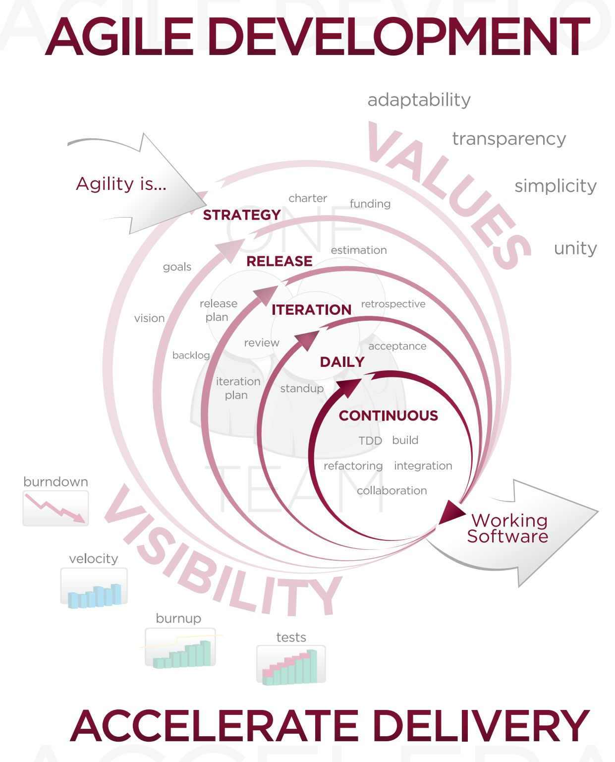An acceptance test has the objective of selling the user on the validity and reliability of the system it verifies that the system procedures operate to system specification and that the integrity of vital data is maintained. I tested the system with large collection of records. The system is found to be user friendly and working efficiently. All the above testing was successfully done.

Agile software development is a group of software development methods based on iterative and incremental development, where requirements and solutions evolve through collaboration between self-organizing, cross functional teams. It promotes adaptive planning, evolutionary development and delivery, a time-boxed iterative approach, and encourages rapid and flexible response to change. It is a conceptual framework that promotes foreseen interactions throughout the development cycle. The Agile Manifesto introduced the term in 2001.

The Agile Manifesto reads, in its entirety, as follows:

We are uncovering better ways of developing website by doing it and helping others do it. Through this work we have come to value:

**Individuals and interactions** over processes and tools

**Working website** over comprehensive documentation

**Customer collaboration** over contract negotiation

**Responding to change** over following a plan

That is while there is value in the items on the right, we value the items on the left more.

* The meanings of the Manifesto items on the let within agile software development context are described below.
* Individuals and Interactions - in agile development, self- organization and motivation are important, as are interactions like co-location and pair programming.
* Working software - working software will be more useful and welcome than just presenting documents to clients in meetings.
* Customer collaborations - requirements cannot be fully collected at the beginning of the software development cycle, therefore continuous customer or stakeholder involvement is very important.
* Responding to change - agile development is focused on quick responses to change and continuous development.

Twelve principles underlie the Agile Manifesto, including:

1. Customer satisfaction by rapid delivery of useful website
2. Welcome changing requirements, even late in development
3. Working website is delivered frequently (weeks rather than months)
4. Working software is the principal measure of progress
5. Sustainable development, able to maintain constant pace
6. Close, daily co-operation between business people and developers.
7. Face-to-face conversation is the best form of communication (co-location)
8. Projects are built around motivated individuals, who should be trusted.
9. Continuous attention to technical excellence and good design.
10. Simplicity
11. Self-organizing teams
12. Regular adaption to changing circumstances

In 2005, a group headed by Alistair Cockburn and Jim High Smith wrote an addendum of Project Management Principles, the Declaration of Interdependence, to guide software project management according to agile development methods.

**CHARACTERISTICS:**

Pair programming, an agile development technique use by XP

There are many specific agile development methods. Most promote development, teamwork, collaboration and process adaptability throughout the life-cycle of project.

Agile methods break tasks into small increments with minimal planning and do not directly involve long-term planning. Iterations are short time frames (time boxes) that typically last from one to four weeks. Each iteration involves a team working through a full software development cycle, including planning, requirements analysis, design, coding, unit testing and acceptance testing when a working product is demonstrated to stakeholders. This minimizes overall risk and allows the project to adapt to changes quickly. Stakeholders produce documentation as required. Iteration might not add enough functionality to warrant a market release, but the goal is to have an available release (with minimal bugs) at the end of each iteration. Multiple iterations might be required to release a product or new features.

**FINDING,**

**SUMMARY**

**&**

**CONCLUSION**

**Findings**

**Tool 1:**

* Maximum Respondents like Logo about New Web Page.
* Maximum Respondents Least like Punch line about the Web Page.
* Maximum Respondents Rate the Web Page in Excellent Response.
* Maximum Respondents like to Remember its main content.
* Maximum Respondents like the Web Page.
* Maximum Respondents impacts the media for a one week.
* Maximum Respondents like Newspaper for Advertising.
* Maximum Respondents like this Website User Friendly.
* Maximum Respondents like to visit the Website again.

**Tool 2:**

* Maximum Respondents like 1000-2000 Budget for this Website.
* Maximum Respondents like Fast Processing to use this software.
* Maximum Respondents like Informative about this Website.
* Maximum Respondents like this Website user friendly.
* Maximum Respondents like the Simplicity of the Website.
* Maximum Respondents doesn’t like any order placing.
* Maximum Respondents like this Website Fulfilling all requirements.
* Maximum Respondents like the Functionality of the Website
* Maximum Respondents like Web Based for this project.

**SUMMARY:**

* There was good response of website.
* Most of Internet Service Providers already use the Website for Management System.
* Some respondents suggested there should be mobile web application for access the Internet Service Provider.
* Some respondents suggested that provided SMS facility for report generation.

**CONCLUSION:**

* To conclude that the webpage is effective media to attract management system attention towards Internet Service Provider.
* This website maintains the records of each and every Registration and Feedbacks, etc.
* Hereby we conclude that this webpage can enrich the customer’s attention towards the Service.

**Correlation of RT1 and RT2**

|  |  |  |  |
| --- | --- | --- | --- |
|  | Yes | No | Correlation |
| RT1 | 83.76068 | 16.23932 | 1 |
| RT2 | 83.76068 | 16.23932 |  |

Observation The Correlation of research tool1 And Research tool2 is 1

The correlation is positive therefore the null hypotheses is rejected

**MAINTAINANCE**

**&**

**EVALUATION**

**6.1 SYSTEM MAINTENANCE AND FUTURE ENHANCEMENT**

**SYSTEM MAINTENANCE:**

Maintenance corresponds to restoring to original conditions, covering a wide range of activities including correcting codes and design errors and updating user support. Maintenance is performed most often to improve the existing software rather than to a crisis or risk failure. The system would fail if not properly maintained.

The software maintenance is an important one in the software development because we have to spend more efforts for maintenance. Software maintenance is to improve the software quality according the requirements. After a system is successfully implemented, it should be maintained in a proper manner. The need for system maintenance is to make the system adaptable to the changes in the system environment. There may be social, economical or technical changes, which affect system being implemented.

Software product enhancements may involve providing new functional capabilities, improving user displays and mode of interaction, upgrading the performance characteristics of the system. So only through proper system maintenance procedures, the system can be adapted to cope with these changes.

We may define maintenance by describing four activities that are undertaken to after a program is released for use.

The first maintenance activity occurs because it is unreasonable to assume that software testing will uncover all latent errors in a large software system. During the use of any large program, errors will occur and be reported to the developer. The process that includes the diagnosis and correction of one or more errors is called corrective maintenance.

The second activity that contributes to definition of maintenance occurs because of rapid change that is encountered in every aspects of computing. Therefore, adaptive maintenance - an activity that modifies software to properly interface with changing environment is both necessary and common place.

The third activity that may be applied to definition of maintenance occurs when a software package is successful. As the software is used, recommendation for new capabilities, modifications to existing functions, and general enhancements and received from users. To satisfy requests in this category, perfective maintenance is performed. This activity accounts for majority of all efforts expended on software maintenance.

The fourth maintenance activity occurs when software is changed to improve future maintainability or reliability, or to provide a better basis for future enhancements. Often called preventive maintenance, this activity is characterized by reverse engineering and re-engineering techniques.

In the software maintenance to improve our software there are two types available

* Reverse Engineering
* Re-Engineering

By using these two techniques, quality of the software can be improved.

* Reverse Engineering means that to update the existing software.
* Re-Engineering means that entirely modifying the existing software.

Maintenance activities involved the following three concepts.

* Enhancement
* Adapting
* Correcting problems

Software product Enhancement may involve providing new functional capabilities, improving user displays and modes of integration, updating external documents and internal documentation, or updating the performance characteristics of a system.

**FUTURE ENHANCEMENTS**

Nothing can be done in single step. Obviously Internet Service Provider has some future enhancements. The enhancements that can improve the value of this application are the following:

1. Descriptive reporting.
2. Facility for mobile application.
3. User have own right to access the website.
4. Anyone can easily access the website.

**6.2USER MANUAL**

* The Web Application Provides Facility of Internet Service Provider.
* It saves time of users by allowing them to Registration.
* Administrator has a privilege to create, modify and delete reports and its particular details.
* User can directly access the website and provide feedback on it.

**ANNEXURE**

**7.1REFERENCE**

**7.1.1 BIBILOGRAPHY**

1. ASP.NET Complete Reference
2. ASP.NET Programming [Black Book]

* Laurence Moroney
* Matthew MacDonald

1. The Complete Reference of SQL server 2008

* James R. Groff & Paul N. Weinberg

**7.1.2WEB SITES REFERRED**

[www.CodeGuru.com](http://www.CodeGuru.com)

[www.w3Schools.com](http://www.w3Schools.com)

[www.synnefoims.com](http://www.synnefoims.com)

[www.jqueryscripts.in](http://www.jqueryscripts.in)

[www.dreamincode.net](http://www.dreamincode.net)

**7.2QUESTIONNAIRE**

***Tool 1:Media***

|  |  |
| --- | --- |
| Name |  |
| Address |  |
| Age |  |
| Gender |  |
| Email id |  |
| Phone no |  |

**Fulfill this Question’s**

Q1.What do you like most about New web page?

* Image
* Logo
* Punch line
* Other

Q2.What did you like Least about the Webpage?

* Image
* Logo
* Punch line
* Other

Q3. How will you Rate this Webpage?

* Excellent
* Good
* Average
* Not Interested

Q4.For how long do you remember a webpage?

* Remember it all
* Remember it slightly
* Remember it’s main content
* Don’t Remember it at all

Q5.Did you like the Webpage?

* YES
* NO

Q6. How Long does a Media Impacts on you?

* Few Hours
* One Day
* One Week
* One Month

Q7.According to you which type of an Advertise gives a Greater Impact?

* Social media
* TV
* Newspaper
* Magazine

Q8. Is this website user friendly?

* YES
* NO

Q9.Would you like to Visit this website again?

* YES
* NO

Q10.Would you like to recommend any of your friends/relatives for this website?

|  |  |  |
| --- | --- | --- |
| Sr.no | Name of the person | Contact no. |
|  |  |  |
|  |  |  |
|  |  |  |

Q11.Give your suggestions

--------------------------------------------------------------------------------------------------------------------------------------------------------------------------------------------------------------------------

***Tool 2: Website***

Q1.What is your Budget for this Website?

* 1000-2000
* 2000-3500
* 3500-5000
* 5000 & Above

Q2.What would make you more like to Use this Website?

* Fast Processing
* Easy-to-use
* User friendly

Q3.If you were describing this Website, what would you say this Website is….. ?

* Boring
* Attention Getting
* Informative
* Strong
* Unique
* Natural

Q4. Is this Website User Friendly?

* YES
* NO

Q5. Do you like the simplicity of the Website?

* YES
* NO

Q6.Do you interest any order placing?

* YES
* NO

Q7. Is the Website Fulfilling all your requirements?

* YES
* NO

Q8. Do you like the Functionality of the Website?

* YES
* NO

Q9. How would you prefer this Website?

* Windows based
* Web based

Q10. Do you want any Updating in Website?

----------------------------------------------------------------------------------------------------------------------------------------------------

Q11.Give your suggestions

----------------------------------------------------------------------------------------------------------------------------------------------------

**7.3 MEDIA PAGE**

